

City of Statesboro
Engineering Department
50 East Main Street
Statesboro, GA 30458
912-764-5468

June 24, 2026

Request for Qualifications/Proposal of Design Services
STM 40: Chandler Rd. at Olympic Blvd Drainage Project

PROJECT LIMITS AND OVERVIEW

The City of Statesboro is requesting engineering services to identify the limitation of the existing drainage conveyance system causing flooding at the intersection of Chandler Road at Olympic Blvd in Statesboro, Ga. and provide a constructable solution along with construction plans. This will include surveying, ROW and Easements, utilities, drainage basin modeling and construction design. The City of Statesboro is soliciting proposals from qualified civil engineering and land surveying firms to provide professional services for a drainage improvement project located in the vicinity of Chandler Road and Olympic Boulevard. The purpose of this project is to evaluate and mitigate recurring stormwater flooding that currently impacts the private community known as Georgia Villas, where runoff backs up within the existing stormwater system and inundates private property.

SCOPE OF SERVICES

The City of Statesboro desires a design professional to provide conceptual drainage improvements along with final civil design including but not limited to: utility relocation, stormwater drainage system improvements, and roadway improvements. Design shall be in accordance with the latest AASHTO, MUTCD, Georgia Department of Transportation Drainage Design Policy Manual and Georgia Department of Transportation Standards and Specifications.

Design Work will be performed in two phases; phases and required deliverables are defined below:

Phase 1, Concept Phase:
- Topographic and Parcel Survey in State Plane Coordinate system
- Concept Plan(s)
- Utility Conflicts identified
- Right-of-Way Conflicts identified
- Preliminary Cost Estimate
- Consultation with City
- 30% Plans for review

Phase 2, Final Design Phase:
- 60%, 90%, and Final Road Design for Review
- Hydrology Study
- Right-of Way Revisions
- Staking of any Required Right-of-Way and Easements
- Construction cost estimate to be used for bidding purposes. The format shall be a MS Excel spreadsheet to be submitted at completion of Preliminary Design, then updated for Final Design and Let for Construction.
- An electronic copy of files and drawings in AutoCAD Civil 3D format, or a format that will convert to AutoCAD, upon acceptance of the completed plans. MicroStation format is acceptable.
- Complete Construction Plans in GDOT Plan Presentation Guide (PPG) Format to include, as applicable:

  - Cover Sheet with PE Stamp
  - Index of Drawings
  - General Notes
  - Typical Sections
  - Summary of Quantities
  - Plan and Profile
  - Grading and Drainage Plans
  - Drainage Profiles
  - Driveway Profiles (as needed)
  - Cross Sections at 50’ intervals
  - Utility Plans based on SUE Level B
  - Signing and Marking Plans (as Needed)
  - Erosion Control plans
  - E&S Control Details
  - Construction Standards and Details
  - Right of way plans (as Needed)

PROJECT SCHEDULE

The City expects the concept design plans for the project to be completed within three (3) months of issuance of the Notice to Proceed. It is necessary for right-of-way & construction easement acquisition to take place immediately following. The City desires to complete final plans within six (6) months of issuing Notice to Proceed.

EVALUATION CRITERIA

Since this is a request for qualifications & proposal (RFQ/P) format, all submitted sealed bids shall be evaluated by the following criteria: (Submittals will be evaluated on a 100-point scale and ranked. At this point, submittals will receive an overall ranking. (Example: 1-10 in the event of 10 submittals)

- Experience with similar projects (25%). Provide information on consultant’s experience and ability in delivering effective services for projects of similar complexity, size, scope, and function. Describe no more than five (5) projects in order of most relevant to least relevant, which demonstrate the consultant’s capabilities to provide services. Include references for project owner.

- Key staff assigned to the project (25%). Provide qualifications and experience on similar projects of key staff assigned to this project in this proposal.

- Project Approach (40%):

  - Provide technical approach to the design and engineering delivery of this project that uniquely separates your firm from other consultants; Any unique skill or service that you as the Consultant offers relative to addressing anticipated design concepts, use of any alternative methods for delivery, and/or management of the project.
  - Identify all challenges associated with design & engineering of this project that separates your firm from other consultants and how your firm intends to avoid, minimize, or mitigate these challenges, including quality control or assurance procedures.
  - Provide any specific qualifications, skills, or knowledge of the project and project area which may uniquely benefit the project.
  - Provide a detailed schedule that includes the scope of design services necessary to deliver final plans suitable for the City to begin construction procurement activities no later than three months from issuance of Notice-to-Proceed with design and engineering.

- Past experience (10%).

A final design cost proposal shall be submitted in a separately sealed envelope to be opened after the consultant selection. The cost shall be for time and materials of services outlined in the Scope of Services above.

-

Submittal Guidelines:
- Cover Page, including project name, date, and company name. Maximum of one page.
- Basic company information including company name, address, contact information, website, staff, and ownership. Maximum of one page.
- Affidavit under O.C.G.A. 13-10-91(b)(1) E-verify. Maximum of one page.
- Signed cover page of any addenda issued. One page for each addendum.
- Project Manager’s experience and qualifications, including education, relevant engineering and/or project management experience, and experience on similar projects. Maximum of two pages.
- Key Staff’s experience and qualifications, including education, relevant experience in applicable areas, and experience on similar projects. Key staff shall include at minimum Principal-In-Charge, Survey, and Design Lead. Submittal may include additional key staff, but no more than five total. Maximum of one page per staff member.
- Prime Consultant’s experience, including relevant projects with description, dates, location and references, relevance to this proposed project, and involvement of key staff. Maximum of two pages.
- Cost Proposal: Include cost proposal for Phase 1 and Phase 2. Cost Proposal will be submitted in a separate sealed envelope from the SOQ, and is not included in the page count.

Failure to adhere to guidelines above, including page counts, may result in disqualification.

MANDATORY PRE-SUBMITTAL CONFERENCE

A mandatory pre-submittal conference will be held on July 23rd, 2026 at 3:00 PM. The conference will be held in a virtual format. Please email bidinfo@statesboroga.gov to receive an invitation to the pre-bid.
RFQ SCHEDULE OF EVENTS

EVENT | DATE | TIME
City issues RFQ/P advertisement | 07/02/26 | -------------
Mandatory Pre-Submittal Conference (virtual) | 07/23/26 | 3:00 pm
Deadline for submittal of requests for clarification | 07/30/26 | 3:00 pm
Deadline for submittal of Statements of Qualifications (SOQs) and Proposals | 08/06/26 | 3:00 pm
City completes evaluations of SOQs | TBD | TBD
Award of contract by City Council (estimated date) | TBD | 5:30 pm

TERMS AND CONDITIONS

- Disqualification: Submissions may be disqualified for: a) receipt of the submission by the City past the stated deadline; b) any irregularities; c) failure to complete requested information correctly; or d) failure to comply with restrictions to firms. If in the opinion of the City of Statesboro, the firm is not in a position to perform the contract, the statement may be disqualified. The City reserves the right to waive any minor informality or irregularities.
- Firms who obtain this RFQ from Georgia Procurement Registry, City website, or from other locations, are advised to re-visit the above websites to obtain any addenda which may be issued prior to the RFQ closing date. The City assumes no responsibility for Firms’ failure to acknowledge any addenda issued.
- Contact: The contact person for this RFQ is Darren Prather, Central Services Director. Explanation(s) desired by Firm(s) regarding the meaning or interpretation of this RFQ must be requested from the contact person in writing via e-mail (bidinfo@statesboroga.gov) or telephone (912-764-0642).
- Non-Discrimination: The City of Statesboro, in accordance with Title VI of the Civil Rights Act of 1964, 78 Stat. 252, 42 U.S.C. 2000d to 2000d-4 and Title 49, Code of Federal Regulations, Department of Transportation, Subtitle A, Office of the Secretary, Part 21, Nondiscrimination in Federally-assisted programs of the Department of Transportation issued pursuant to such Act, hereby notifies all bidders that it will affirmatively ensure that in any contract entered into pursuant to this advertisement, disadvantaged business enterprises as defined at 49 CFR Part 23 will be afforded full opportunity to submit bids in response to this invitation and will not be discriminated against on the grounds of race, color, national origin, or sex in consideration for an award.
- Lawsuits/Bribery: Prospective firms shall disclose any record of pending lawsuits, criminal violations and/or convictions, etc., conflicts of interest, or contract defaults.
- Liability: The City is not liable for any cost incurred in the preparation of the submission. Nor is the City bound by any information provided unless reduced to writing and distributed as a written addendum.
- Clarification of submittals: The City reserves the right to seek clarification of any point in a respondent's submission, or to obtain additional information.
- Exceptions: Conditional submissions or those that take exception to the specifications will be considered only at the discretion of the City Engineer.
- Award: Award, if made, may be with the firm that is selected by the review committee based on scoring using the evaluation criteria set forth herein; however, the purchaser reserves the right to reject any and all submissions and to waive technicalities or informalities associated with the submission, and to make the award that it deems is in the best interest of the purchaser. The firm to whom the award is made will be notified at the earliest possible date. The purchaser reserves the right to reject any submission from a firm who has previously failed to perform properly, or to complete on time contracts of a similar nature.
- Insurance: The selected firm shall provide proof of purchase from and maintain with a company or companies authorized to do business in the state of Georgia the following types of insurance:
  - Statutorily required workers’ compensation insurance.
  - Commercial general liability insurance, with an endorsement naming the County as
an additional insured, and with limits of not less than $1,000,000.00 per occurrence and $1,000,000.00 aggregate.
  - Motor vehicle liability insurance with limits of not less than $1,000,000.00 for bodily injury to or death of one person in any one accident, and not less than $2,000,000.00 because of bodily injury to or death of two or more persons in any one accident; and not less than $250,000.00 because of injury to or destruction of property.
  - Professional malpractice insurance (i.e., errors and omissions insurance) in an amount not less than $1,000,000.00 per occurrence.

Location Map:
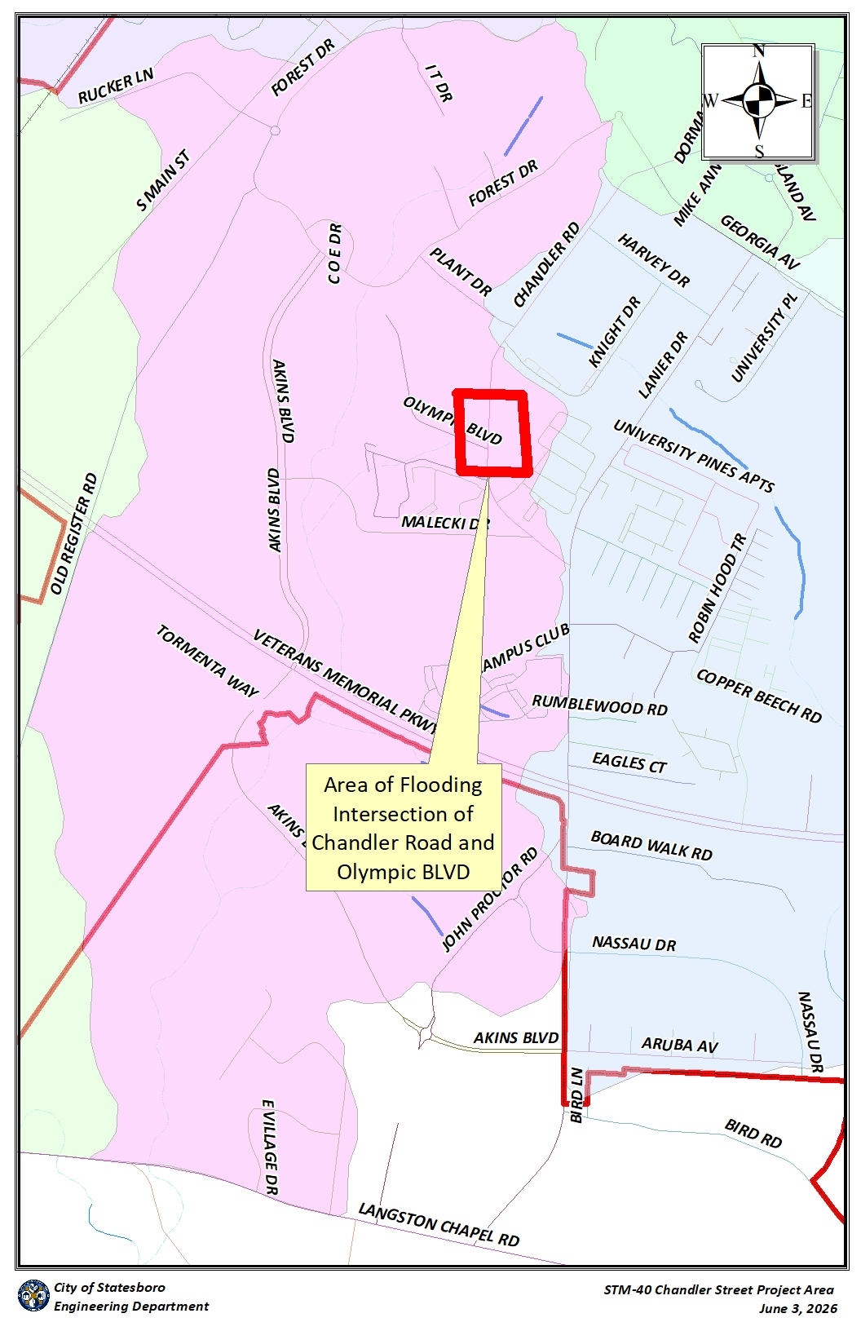

Contractor Affidavit under O.C.G.A. § 13-10-91(b)(1)
By executing this affidavit, the undersigned contractor verifies its compliance with O.C.G.A. § 13-10-91, stating affirmatively that the individual, firm or corporation which is engaged in the physical performance of services on behalf of Bulloch County, Georgia has registered with, is authorized to use and uses the federal work authorization program commonly known as E-Verify, or any subsequent replacement program, in accordance with the applicable provisions and deadlines established in O.C.G.A. § 13-10-91. Furthermore, the undersigned contractor will continue to use the federal work authorization program throughout the contract period and the undersigned contractor will contract for the physical performance of services in satisfaction of such contract only with subcontractors who present an affidavit to the contractor with the information required by O.C.G.A. § 13-10-91(b). Contractor hereby attests that its federal work authorization user identification number and date of authorization are as follows:

_________________________________ _____________________
Federal Work Authorization E-verify Company ID# Date of Authorization

_________________________________
Name of Company

_________________________________
Name of Contractor

STM 40: Chandler Rd. at Olympic Blvd Drainage Project
Name of Project

City of Statesboro, Georgia
Name of Public Employer

I hereby declare under penalty of perjury that the foregoing is true and correct.
Executed on ____________, _____, 20____ in _________________ (city), ____ (state).

_________________________________
Signature of Authorized Officer or Agent

_____________________________________________
Printed Name and Title of Authorized Officer or Agent

SUBSCRIBED AND SWORN BEFORE ME
ON THIS THE ______ DAY OF _________________,20____.

_________________________________
NOTARY PUBLIC

My Commission Expires:

* As of the effective date of O.C.G.A. § 13-10-91, the applicable federal work authorization program is the "EEV/Basic Pilot Program" operated by the U.S. Citizenship and Immigration Services Bureau of the U.S. Department of Homeland Security, in conjunction with the Social Security Administration (SSA).

