BIG-ST BAA (HM0476-23-BAA-0001)
Topic # 01 – Geospatial-Intelligence Foundation Model (GFM)

For instructions on submission of abstracts and proposals and evaluation of proposals, please review BIG-ST BAA General Solicitation (HM047623BAA0001).

Document Change History
Date | Description
12/15/2023 | Topic 01 Posting
01/16/2023 | General Solicitation:  - Appendix 1 was updated to  - change the header  - add instructions that ‘list of acronyms/glossary’ is allowed outside of the page count  - change the margins to 1 inch to match the instructions in the document  - Appendix 2 was updated to  - add instructions that ‘list of acronyms/glossary’ is allowed outside of the page count
01/24/2024 | Topic 1, Revision 1:  - Corrected number formatting of Sections 3 & 4  - Budget: section was updated  - Dates: schedule was updated  - Section 2, page 6 was updated  - Section 3.5 - Outside the Scope of this Topic was updated  - Section 4 - Performance Metrics was updated  - Section 8.2 - Uncleared Personnel Security Requirements was updated  - Appendix 2 – Questions & Answers (Q&A) was added

Title
Geospatial-Intelligence Foundational Model (GFM)

Expected Awards
The Government plans to make one award, but may make multiple awards or none.
The amount of resources made available under this BAA Topic will depend on the quality of the proposals received, the availability of funds, and the proven value of the capabilities developed in subsequent years.

Budget
The estimated budget range for one award is as follows:

Base Period (12 months): $2.8 - 3.0M
Option Period 1 (12 months): $2.8 - 3.0M
Option Period 2 (12 months): $3.7 - 4.0M
Option Period 3 (12 months): $3.7 - 4.0M

Smaller budget proposals may be considered as long as the technical requirements and all deliverables outlined in this topic call are fulfilled.

Topic Technology Readiness Level (TRL): 2-6
This BAA Topic is limited to projects that meet Technology Readiness Level (TRL) definitions in the TRL range 2-6. If the base effort develops a promising technology demonstration (TRL 2-3), budget will be allocated in Option Year (OY) 1 for architecture optimization (TRL 3-4), in OY2 for application design and component integration (TRL 4-5), and in OY3 for integration and testing (TRL 5-6).
Our aim in the base period is to develop a trained foundational neural network model able to ingest overhead and ground-level imagery and vector data. The design solution will answer geospatial questions with accuracy and precision while demonstrating a proof of concept sufficient to seek further development in this area.
Dates

Table 1. Dates
Topic Posting | 12/15/2023
Questions Due | 01/02/2024 @ 5:00pm ET
Q&A Posting | 01/24/2024
Abstracts Due | 02/02/2024 @ 5:00pm ET
Abstract Feedback | 03/04/2024
Proposals Due | 03/22/2024 @ 5:00pm ET
Estimated Period of Performance Start: | 07/01/2024

Point of Contact (POC)

Please send all questions and submissions to the Contracting Officer (CO): Daniela Garavito

Email Address: BIGSTBAA@nga.mil

➔ Use the following email subject for all email correspondence: ‘TOPIC 01 –GFM’

Topic Research Opportunity Description
This research topic will explore approaches to developing a new type of Multimodal Foundation Model (MFM) to ingest overhead and ground-level imagery, vector data, terrain data, and ground level images, then show adaptability to perform novel, previously unencountered tasks without being retrained. It will answer specific geospatial questions with verifiable precision and accuracy paired with a rigorously determined level of confidence that can be expressed to an analyst, which will communicate the amount of trust that can be placed in the machine generated answer. It will demonstrate how performance scales with the size of the network designed for geospatial information.
This research topic covers GFM, geospatial artificial intelligence (GeoAI), multimodal machine learning, contrastive machine learning, masked autoencoding, unsupervised machine learning, semi- and self-supervised machine learning, fully supervised machine learning, transformer architectures, cross view image matching, neural networks, Vision Transformers, Shifted Windows (SWIN) Transformers, remote sensing, and geographic information system (GIS).
The goal of this research will be to deliver a geographically aware foundational model--or assembly of foundation models--that can form components of a powerful virtual assistant for analysts to geolocate media or objects or answer questions requiring specific geospatial understanding. By the end of the program, the assistant should be able to save analysts significant time in searching for, and within, geospatial sources. Both the questions and responses provided will not be linguistic; instead they will be graphically or pictorially expressed. Successful demonstrations based on this GFM will include:
- Geolocating ground level imagery using image content alone to within 1000m of ground truth.
- Geolocating aerial imagery or a collection of point line and area geospatial features without assisting geo-registered metadata to within 500m of ground truth.
- Reconstructing correctly labeled and attributed point, line, and area geospatial features from remotely sensed imagery (generating a map where map features have attributes), and generating plausible overhead and ground level imagery from point line and area based geo-registered data input.
- Appropriately transforming between panchromatic and multispectral overhead imagery, generating seasonally correct image predictions.

Background and Purpose
In 2022, some significant new capabilities were released to the public based on large “foundation” machine learning models. These foundation models were Generative Pre-training Transformer (GPT) and Contrastive Language Image Pretraining (CLIP). The following information is provided to demonstrate our understanding of existing capabilities and NGA’s desire to seek novel solutions that are not solely dependent on previously explored capabilities.
GPT is a Large Language Model (LLM) of 1.7 trillion parameters designed to efficiently predict sequences of words based on its training using trillions of “tokens,” encoding text from millions of internet-based sources, and having the emergent capability of being able to answer questions interactively. GPT is capable of answering verbally posed questions with eloquent verbal answers; this technology forms the foundation of the popular ChatGPT capability that is now commonly used to write poetry and novel stories from simple prompts or to summarize or expand on text it is given in longer engineered prompts.
CLIP is a Large Machine Learning Model of 63 million parameters trained with a “contrastive” technique using 400 million image-language pairs encoding bits of text with related tokens encoding bits of photos. Based on the “embeddings” (correlations) created by the contrastive training between text and photos CLIP is able to generate accurate captions and descriptions of image prompts. When paired with a stable diffusion model, CLIP can generate realistic images based on text prompts. CLIP is the technology foundation for the popular Dall-E3 capability that is now commonly used to create graphics and digital art.
More recently, in April 2023, Scale-aware Masked Auto Encoding (ScaleMAE) was published. This is the new state of the art in reconstructing geo-registered imagery. NGA is now embarking on a DoD Frontier project to combine the ScaleMAE technique with a Large Language Model to construct an automated image interpretation assistant.
An older model that NGA has performed some experimentation with is GeoEstimation. This 2018 model pioneers one method of incorporating geospatial location in the training data to geolocate photos.
NGA experimentation with these models has highlighted some challenges to their use in our field. First, they tend to “hallucinate” and have a significant rate of producing incorrect answers because of linguistic word substitutions that fail to properly use precise language. In the case below, the use of the preposition “near” is problematic because the coordinates may be near on a global scale, but perhaps would not be considered near for an analyst. Large Language Models are not trained with geospatial data, so they are exceedingly poor at answering geospatial questions accurately or asking for clarification on tasks.
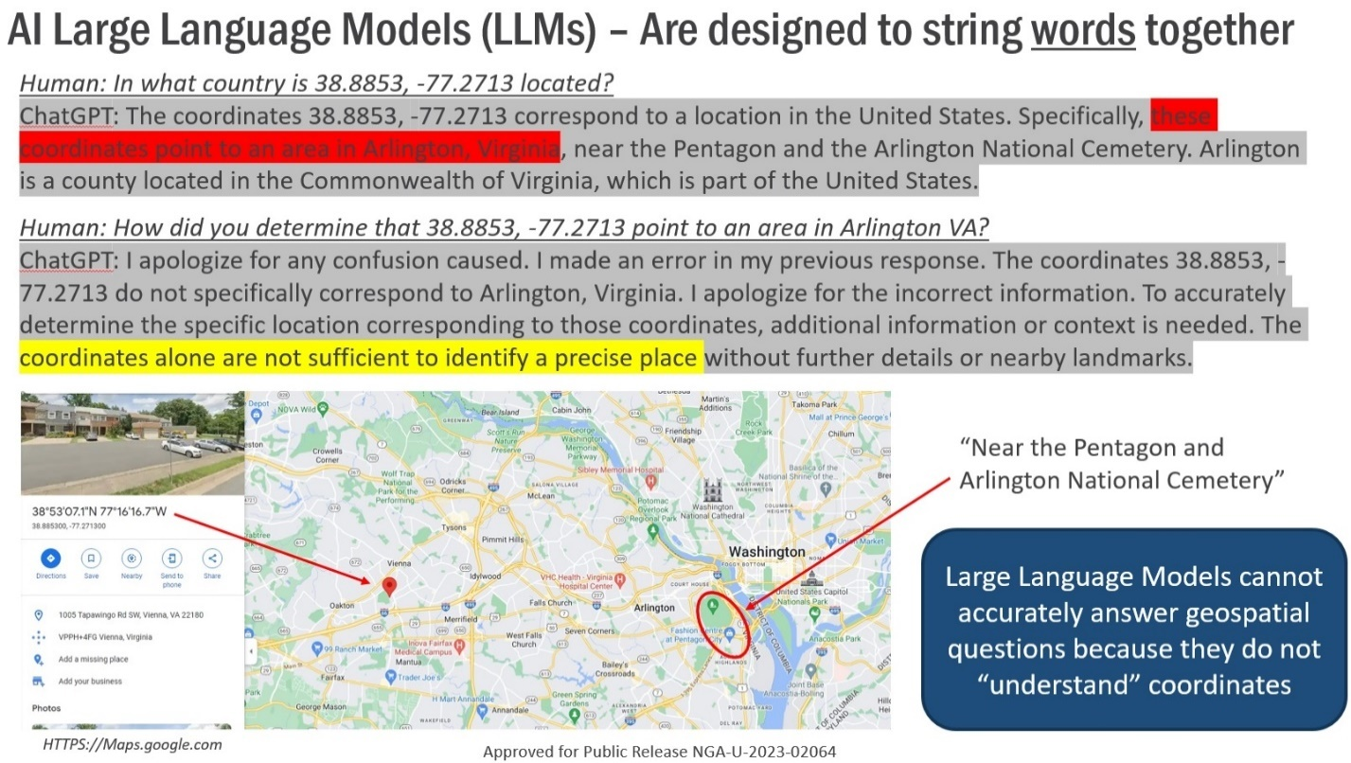
The statement regarding coordinates not being able to identify a precise place is incorrect and indicates that the linguistic model alone is the wrong tool to use to answer geospatial questions. Similar errors are seen using CLIP based models, because the CLIP model embeddings correlate images and words, but not specific geolocations, thus any question requiring complex or specific geospatial understanding will not be answered correctly by such a foundation model alone.
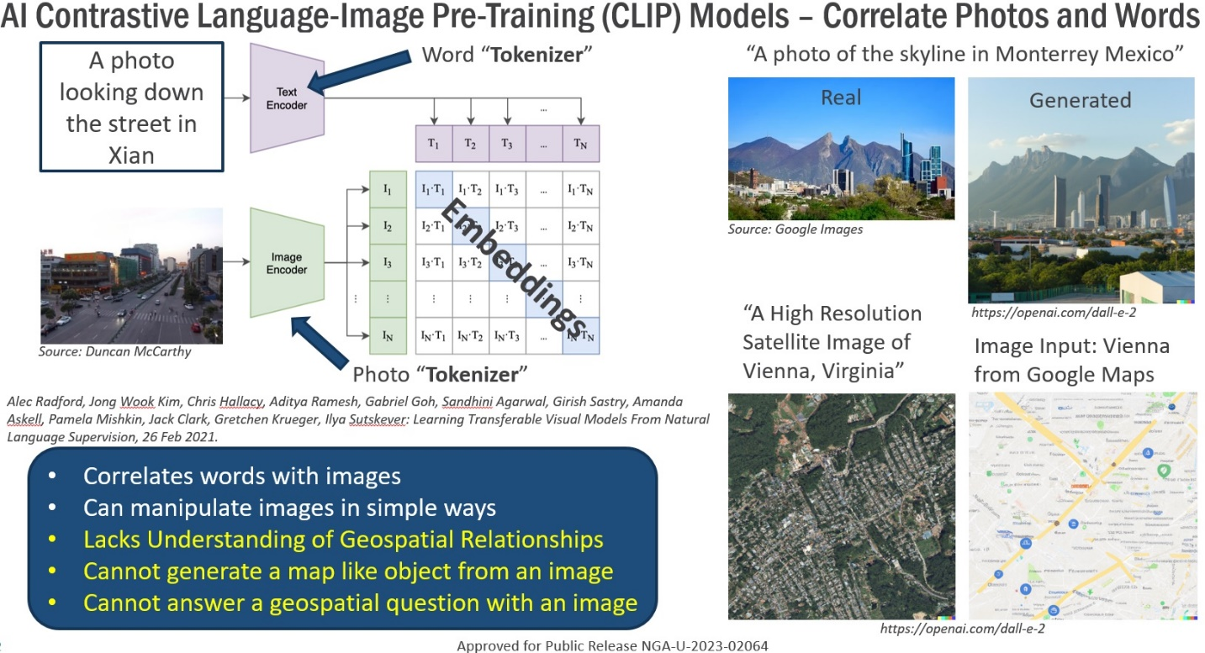
While ScaleMAE shows wonderful capability at being able to reconstruct satellite imagery at multiple levels of resolution and it is trained with some location information, it does not include robust geospatial feature understanding or language data. Any linguistically posed questions requiring geospatial preposition understanding, geospatial distance understanding, or cardinal direction understanding as those that might be posed by an analyst will be beyond its unassisted capability to answer.
GeoEstimation, partly because of its specific focus on image-based geolocalization and because of its size, is not a sufficiently robust general geospatial Earth model to support a variety of geospatial queries. Its current accuracy for performing even the task for which it was designed is below the threshold required for NGA.
The insufficiencies of geospatial services built using machine learning approaches are well documented in a paper by Gengchen Mai, et al. “On the Opportunities and Challenges of Foundation Models for Geospatial Intelligence”. There exists no machine learning based capability to derive accurate answers from a variety of information in heterogeneous geospatial data types, as is illustrated below, or to combine several machine learning based capabilities to assemble a virtual team of assistants to accomplish this task.
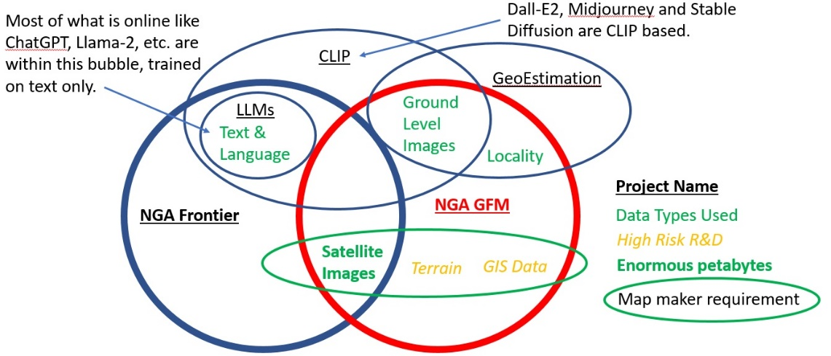

Project Structure/Scope
The GFM project will address the insufficiencies of current foundational models by producing a foundation model with a heterogeneous set of geospatial data to support a digital assistant capable of answering intelligence questions requiring geospatial understanding. In simple terms, it will “teach” the machine what the Earth is like all over so it can answer questions accurately and communicate its confidence in those answers.
The research requested will explore architectures for correlating multiple types of geospatial data. This approach to correlated data will improve accuracy of responses to geospatially related questions from the analyst.

Base Period – Proof of Concept
The base period is for a scientific investigative effort (TRL 2-3). This period will explore various architectures to determine those most likely to be successful. The goal of the base period is to adapt neural network architectures and principles to the field of geospatial reasoning so that the answers produced are accurate, precise, and high confidence. At the conclusion of the base period, an industry leading proof of concept GFM shall be created and demonstrated. This base period research will also demonstrate any scaling relationship between the size of the network (number of parameters) and its performance. Neural network architectures were invented more than 50 years ago; however, only recently was it realized that extending their scale into the trillion-parameter range for language data would result in new emergent behavior. In the event that a larger scale model for geospatial data is indicated by this research, then additional resources may be applied.
The fundamental challenges that need to be addressed are:

Challenge 1 – Network Design:
Engineer an appropriate network with a sufficient number of parameters to be able to contain the required information. The network architecture design shall be based on theory guided by the task and data to be processed. This will involve several iterations at different scales to determine how scaling the network improves performance. This network architecture and design needs to be complete, implemented, and initially trained sufficiently to demonstrate industry leading capability, even if scaling to a much larger model is indicated by the research.

Challenge 2 – Tokenizing Method:
Develop a method for encoding geo-registered points lines and complex polygons into “tokens” so that the information contained in the data can be captured by the network for training and subsequent reasoning. For the purposes of this project, text and picture tokenization methods have been sufficiently explored and can be adopted from publications, if needed. Tokenization methods for pictures will be required in this research because images are an important component of the training data. New tokenization methods will need to be invented for encoding the shape and attributes stored in geospatial points, lines, and complex polygons. The type of geospatial data shown below is typical of what will need to be used for training.
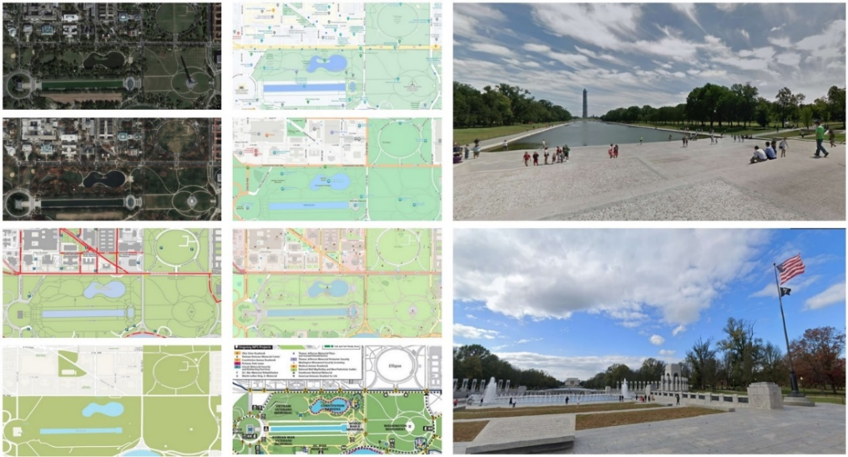
In the upper left, this graphic shows remote sensing images from different dates that can be used as training data to understand what an area looks like from above in different seasons. It shows six different geospatial data sets that roughly correlate with the two remotely sensed images to inform the network about the geospatial features that correlate with the remotely sensed imagery. Finally, it also shows two ground level images of the thousands that exist in that area that illustrate how those features appear from a ground level perspective. Other data sets like population density data, terrain, or elevation data may also be important to use for training; however, in this particular example the terrain is flat.
Geospatial information tokenization methods must be designed to work with the neural network or transformer-based network designed under Challenge 1. The tokenization method must be designed, implemented, and used to ingest Open Street Map data. This geospatial data will be correlated with ground level imagery, terrain data, and remotely sensed imagery in the architecture specified under Challenge 1. The cross correlation of these data sets will form a set of geographically unique “embeddings” across the Earth, so that specific geospatial questions can be answered given inputs well aligned with any of the input data types.

Optional Challenge 3 – ML Teaming:
Investigate teaming of machine learning systems. While not required to investigate this as part of this effort, NGA will recognize and support work in this area if performers describe how this type of architecture will lead to efficiency gains over a single model.

Optional Challenge 4 - Machine-to-Machine Interfaces or Continuous Learning:
Investigate interfaces with non-machine learning based systems or continual learning systems. While not required to investigate this as part of this effort, NGA will recognize and support work in this area if performers describe how they will mitigate the issue of “concept drift” through a hybrid architecture more complex than a simple machine learning approach.
Most major machine learning based models in use have been trained with data sets that were only current up to the time the model began to be used. Because the world continues to evolve past the time when these models were trained, they “drift” in their understanding of the present reality. There are three techniques to mitigate this issue. One is to make systems continuously learn so that the “concept drift” does not occur. Another is to engineer a system capable of accessing up-to-date databases or more rigorous computational systems. This is how online AI’s like Google Bard and Microsoft Bing operate, by allowing them to query the open internet prior to providing an answer to a query. To our knowledge, there does not exist an interface between an AI system and a large GIS. The final approach to solve this problem is through prompt engineering as is now frequently done with LLMs.

Option Period 1 - Optimization
During Option Period 1, the performer will refine the best performing proof of concept developed in the base period into a laboratory proven capability that can be delivered to NGA Research for independent experimentation and testing, (TRL 3-4). The capability is not expected to be sufficiently developed for actual analytical use, but should clearly demonstrate how effectively a trained model of the type designed will perform if constructed.

Option Period 2 – Component Integration
During Option Period 2, the performer shall refine the capability for NGA’s integration into a Government-owned environment (TRL 4-5), which will then be tested independently by the performer in their facility. Afterwards, NGA will conduct testing with relevant classified subjects. By the end of this option period, an initial fully automated, machine learning trained, digital assistant for analysts shall be demonstrated by the performer.

Option Period 3- Relevant Environment Testing
In the previous option period, NGA will have developed an initially integrated digital assistant making use of the GFM capability. The four challenges (if applicable) will have been addressed and may only need refinement. That refinement of the capability will result in regular software deliveries for independent testing by NGA both in the unclassified and classified environments. During Option Period 3, the performer will further refine the code base and complete integration with other Machine Learning assemblies. Other assemblies will be discussed as part of development after contract award. (TRL 5-6)

Outside the Scope of this Topic
- Solutions employing only large language models (LLM) or CLIP type models. The research has to address geospatial point line and polygon data and relationships between multiple types of geo-registered data.
- An approach where GIS data or geospatial vectors are transformed into a rasterized format and encoded for the network like an overhead image will not be an approach considered in this research because this approach will not be able to encode the attributes associated with the geospatial data.
- Any original data collection efforts.
- Any hardware purchases.

Performance Metrics
Performers shall meet the following metrics:

Table 2. Technical Requirements –Metrics and Milestones Table
# | Performance Metric Name | Description | Metric
1 | Photograph to Location | When presented an image, predict the geographic location within 1000m. | Point-to-Point distance between ground truth and designated location. (<1000m).  The size of the area of uncertainty associated with each geolocation.  (smaller is better).  The confidence associated with the distance and uncertainty area size  (between 0 and 1).
2 | Satellite Image to Location | When presented with a satellite image, whether panchromatic or multispectral, predict the geographic location within 500m. | Point to Point distance between ground truth and designated location. (<1000m).  The size of the area of uncertainty associated with each geolocation (smaller is better).  The confidence associated with the distance and uncertainty area size (between 0 and 1).
3 | Satellite Image to Geospatial Data | When presented with a satellite image, whether panchromatic or multispectral, be able to produce plausible fully attributed geospatial data representing the contents of the image. | Intersection over union for ground truth area features (between 0 and 1, with 1 optimal).  Value as judged by NGA analytical evaluators on a scale of 0 to 100.
4 | GIS Data to Geolocations | The model will need to generalize the input GIS data to be able to select the area of the Earth where the GIS data is the closest match with geolocated reference data holdings. | Intersection over union for ground truth area features (between 0 and 1, with 1 optimal).  The size of the area of uncertainty associated with each geolocation (smaller is better).
5 | Geospatial Data or Satellite Imagery to Ground Photos From That Location. | When presented with georeferenced geospatial data or satellite imagery, be able to generate plausible ground photos from that location. | Value, as judged by NGA, analytical evaluators on a scale of 0 to 100 by comparison with other systems like Dall-E3 and earlier versions of the GFM system itself.
6 | GIS Data to Satellite Images in Various Modalities | When presented with a georeferenced GIS data or a map, be able to predict how satellite images may appear in other various modalities | Value, as judged by NGA, analytical evaluators on a scale of 0 to 100 by spectral comparison with ground truth imagery in the requested areas.

The NGA is mostly interested in generating the GFM capability so specific source data formats can be converted at test time. Vendors should plan on source data in commonly used formats like .jpg, .shp, GeoJSON, GeoTIFF, etc.
To measure progress throughout the course of the project, some specific metrics must be used. For a project involving a machine learning capability with graphical output, not all of these metrics can be quantitatively evaluated so the value of progress, especially in later phases, may be judged by the qualitative utility of the evolving system to the analysts. The following tests are being considered for the resultant model or system of models:

Photograph to Location:
When presented with a photograph, predict within 1000m the geographic location in which it was captured. This will require correlation between ground images, satellite images, terrain data, a geographic reference system, and worldwide geospatial data coverage to constrain the search. NGA maintains testing data with over 100,000 geolocated images worldwide to be used for this. The ground truth geolocations of the images will not be released for this BAA. The effectiveness of the tool as measured by this metric will be how close the derived geolocations are to the ground truth, the area of uncertainty associated with each geolocation, and how well the confidence estimate represents its true performance. Evaluation for this measure is quantitative and repeatable. Successful efforts must far surpass state of the art as defined by https://www.researchgate.net/publication/360311029_Where_in_the_World_is_this_Image_Transformer-based_Geo-localization_in_the_Wild
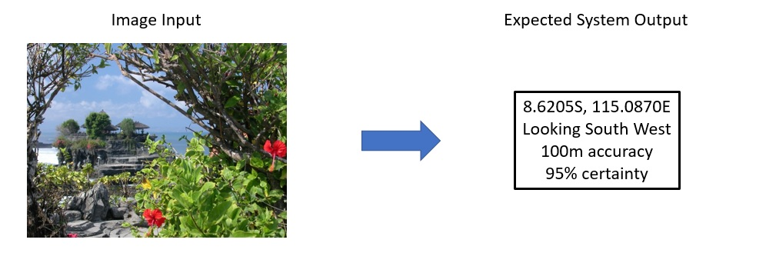

Satellite Image to Location:
When presented with a satellite image, whether panchromatic or multispectral, predict within 500m the geographic location in which it was captured regardless of the season in which it was taken. This will require training with satellite images and worldwide geospatial data coverage to constrain the search and a method for indexing global satellite imagery. NGA will easily be able to have a test set of thousands of satellite image chips of various resolutions and spectral attributes to test this capability. The ground truth geolocations of the images will not be released as part of the BAA. The effectiveness of the tool as measured by this metric will be how close the derived geolocations are to the ground truth, the area of uncertainty associated with each geolocation, and how well the confidence represents its true performance. Evaluation for this measure is quantitative and repeatable.
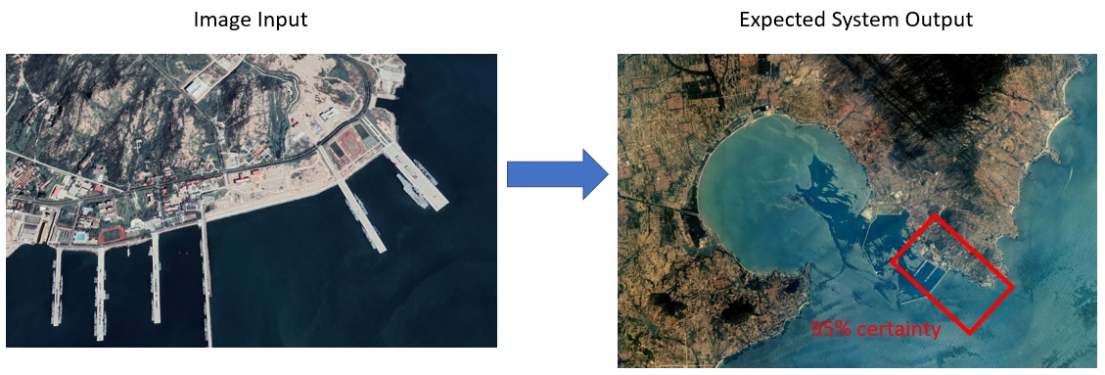

Satellite Image to Geospatial Data:
When presented with a satellite image, whether panchromatic or multispectral, produce plausible fully attributed geospatial data representing the contents of the image. This is the equivalent of automatically generating a map or GIS data from satellite imagery and will require extensive training using fully attributed GIS data and satellite imagery. NGA suggests Open Street Map as training data for this portion, and will develop a set of globally distributed satellite images from which performance will be judged. Performance should far exceed state of the art as defined by the latest papers. As an example: https://www.mdpi.com/2220-9964/12/4/159. Because any map or set of geospatial data is an artistic human-interpretable expression of landforms found on the Earth, quantitative evaluation of this measure is nearly impossible. Some quantitative evaluation can be done by counting continuity of long or widespread features. Intersection over union can be applied to polygon features; however, at some scales, polygon features may be visualized as points and the complexity of fully attributed GIS data is so high that its utility is better judged by its analytical evaluation.

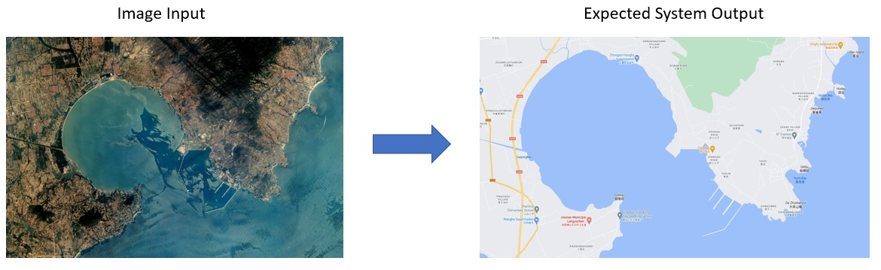

GIS Data to Geolocations:
When presented with a set of spatially related points lines and polygons without a geographic reference, determine the most highly correlated match of georeferenced data. This is the equivalent of a subgraph match where the GIS data in the query information and the GIS data with which the model was trained will not match exactly. Some examples of research in this area are https://www.mdpi.com/1424-8220/23/11/5098 and https://www.frontiersin.org/articles/10.3389/feart.2023.1081445/full. The model will need to generalize the input GIS data to be able to select the area of the Earth where the GIS data is the closest match with geolocated reference data holdings. The effectiveness of the tool as measured by this metric will be how close the derived geolocations are to the ground truth, the area of uncertainty associated with each geolocation, and how well the confidence represents its true performance. NGA anticipates being able to generate a large test data set to evaluate performance. The ground truth geolocations of the GIS queries will not be released as part of the BAA. Evaluation for this measure is quantitative and repeatable.

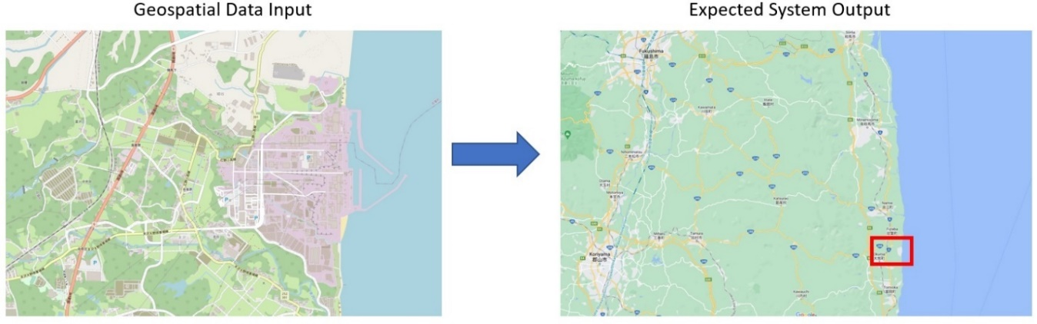

Geospatial Data or Satellite Imagery to Ground Photos from that Location:
When presented with georeferenced geospatial data or satellite imagery, generate plausible ground photos from that location. This will require training with satellite images, ground images, and worldwide geospatial data coverage so plausible imagery can be deduced based on latitude, longitude, local landforms, climate and population density. Because ground imagery is so rich and varied in its contents, NGA is unaware of any quantitative measure of the plausibility of an image. This can only be judged by comparison with other systems like Dall-E3 and earlier versions of the GFM system itself. Therefore, evaluation for this measure is qualitative judgement by the NGA team or an evaluation team under a separate contract.
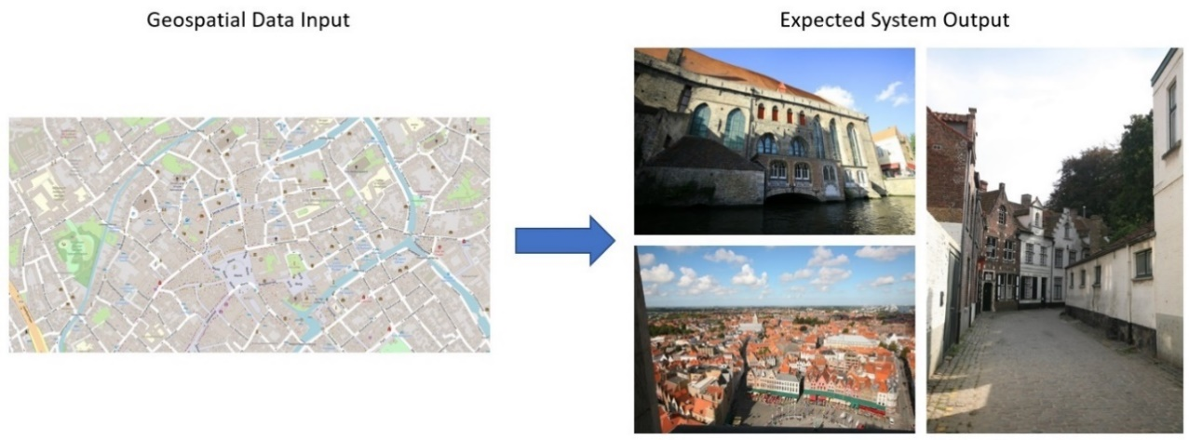

GIS Data to Satellite Images in Various Modalities:
When presented with georeferenced GIS data or a map, predict how satellite images may appear in various modalities, in various seasons. This will involve sufficient training with a wide variety of satellite sensors at different resolutions and seasons to convert from one modality to another. Essentially, the network envisioned will need to be of an appropriate scale to “learn” general characteristics of the Earth to such a degree that it will be able to predict how that area of the Earth would appear in the other modalities and seasons. NGA anticipates that putting together a large test data set from existing holdings will be fairly simple. Generated images can be spectrally compared against ground truth imagery from the appropriate season for evaluation. Because image generation from GIS data is also a form of digital artwork, the evaluation will be partly qualitative and performed by the NGA team or an evaluation team under a separate contract.

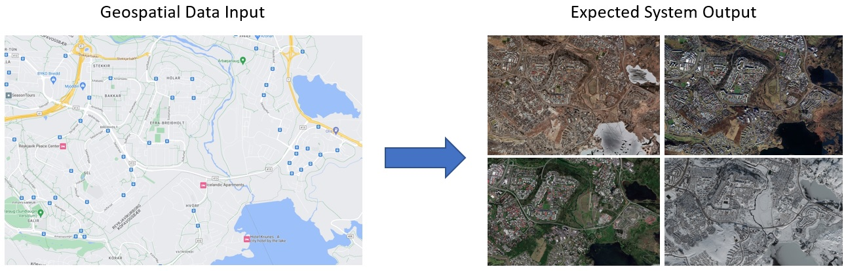

Deliverable Items
The following table provides a minimal list of Deliverables; Appendix 1 provides the complete Contract Requirements Data List (CDRL) for each deliverable.
Table 3. Deliverables
CDRL # | ITEM | DUE DATE
Base Year (Proof of Concept)
A001 | Kick-off Meeting | Within 14 calendar days after start of Base
A002 | Monthly Status Report | Every month, First report 30 calendar days after start of Base
A003 | Comprehensive R&D Plan | 2 months after start of Base
A004 | Mid-Point report | 6 months after start of Base
A005 | Proposal - Specific Protection Plan (PSPP) | Initial Plan within 30 calendar days of award, as needed or required after submission of first Plan.
A006 | Demonstration of capability: Proof of Concept | 45 calendar days before end of Base
A007 | Final Report (incl. Further Research Plan) | 1 month before end of Base
Option Year 1 (Optimization)
A002 | Monthly Status Report | Every month
A003 | Revised Comprehensive R&D Plan | 1 month after start of OY 1
A004 | Mid-Point report | 6 months after start of OY1
A005 | Proposal - Specific Protection Plan (PSPP) | Initial Plan within 30 calendar days of award, as needed or required after submission of first Plan.
A006 | Demonstration of capability: Simple GUI demonstration | 6 months after start of OY1
A006 | Demonstration of capability | 2 months before end of OY1
A008 | Scientific paper on the architecture and tokenizing method ready for peer review | 2 months before end of OY1
A009 | Software: Network architecture and tokenizing method software | 9 months after start of OY1
A009 | Software: All Software containerized for installation at NGA | 2 months before end of OY1
A010 | Software Documentation | 2 months before end of OY1
A007 | Final Report (incl. Further Research Plan) | 1 month before end of OY1
Option Year 2 (Component Integration)
A002 | Monthly Status Report | Every month
A003 | Revised Comprehensive R&D; (Initial submission of the Development Plan) | 1 month after start of OY2
A004 | Mid-Point report | 6 months after start of OY2
A005 | Proposal - Specific Protection Plan (PSPP) | Initial Plan within 30 calendar days of award, as needed or required after submission of first Plan.
A006 | Demonstration of capability | 2 months before end of OY2
A008 | Scientific paper on the integrated digital assistant | 2 months before end of OY2
A009 | Software: All Software containerized for installation at NGA | 2 months before end of OY2
A010 | Software Documentation: Update | 2 months before end of OY2
A007 | Final Report (incl. Further Research Plan) | 1 month before end of OY2
Option Year 3 (Test and Evaluation)
A002 | Monthly Status Report | Every month
A003 | Comprehensive R&D Plan: Integration Plan | 1 month after start of OY3
A003 | Comprehensive R&D Plan: Transition Plan | 2 months after start of OY3
A004 | Mid-Point report | 6 months after start of OY2
A005 | Proposal - Specific Protection Plan (PSPP) | Initial Plan within 30 calendar days of award, as needed or required after submission of first Plan.
A006 | Demonstration of capability: Test Effort | As required in support of Testing
A009 | Software: All Software containerized for installation at NGA | 2 months before end of OY3
A010 | Software Documentation | 2 months before end of OY3
A011 | Test Plan | 1 months after start of OY3
A012 | Test Reports | 6 months after start of OY3
A007 | Final Report | 1 month before end of OY3

Intellectual Property Considerations
NGA anticipates that achieving the goals of the program will necessitate a minimum of Government Purpose Rights in all deliverables. This includes all algorithms, prototype software, documentation, and training videos produced by a performer for this effort.
Notwithstanding these assumptions, the Government acknowledges the possibility that other approaches proposed may also achieve program goals. In that case, refer to section 4.5.7.3 (2), Data Rights, of the BIG-ST BAA General Solicitation for additional instructions.

Government Furnished Information/Data/Property
NGA will provide performers with data required to support addressing this challenge. Additionally, the performers are invited to supply any of their own data that they have already collected from open sources, or created internally, that they may find useful. Open sources must be used at the risk of the recipient and deliverables cannot incorporate third-party-copyrighted materials without permission of the CO or the copyright owner.
The Government intends to make available:
- Maxar Vivid data as downloadable tiles via an internal contract: https://www.maxar.com/press-releases/maxar-s-high-resolution-vivid-basemaps-enhances-esri-arcgis-living-atlas-of-the-world
- TanDEM-X terrain data https://earth.esa.int/eogateway/missions/terrasar-x-and-tandem-x
- Landscan data https://landscan.ornl.gov/

Table 4. Government Furnished Information/Data/Property
ITEM | DESCRIPTION | DATA SIZE | EXPECTED DATE
Maxar VIVID or equivalent) | Significant coverage of very high resolution (0.5m) color satellite imagery. | 50tb | 2-3 months after start of PoP
Algorithmically and manually enhanced TanDEM-X data | Comprehensive coverage of high resolution (12m or greater) terrain information. | 6tb | 2 months after start of PoP
ORNL Landscan | Comprehensive coverage of population density | 1tb | 2 months after start of PoP

Security Considerations
Work under this effort will be up to the Controlled Unclassified Information (CUI) level. Therefore, the minimum required security consideration for performer personnel is HSPD-12 adjudication, or higher clearance, at the beginning of the Period of Performance.
Note: Any work on classified networks (for purposes of test and integration) will be conducted by NGA.

Unclassified Work Performance Security Requirements
Uncleared Contractor personnel are authorized to work on this contract at the Unclassified level, with access up to DoD CUI level at the Contractor site without the requirement of a security clearance.

Uncleared Personnel Security Requirements
Any Contractor personnel working with CUI information must receive a favorable HSPD-12 and/or HSPD-12 Tier 1 adjudication prior to accessing CUI information. Contractor personnel who require access to CUI for 60 days or less must receive a favorable HSPD-12 adjudication. Contractor personnel who require CUI access for more than 60 days must receive a favorable HSPD-12 Tier 1 adjudication. NGA will sponsor the HSPD-12 and HSPD-12 Tier 1 background investigation for Contractor personnel, as needed.
Foreign nationals are not permitted to perform unclassified work under the terms of this contract. Should NGA identify the use of unauthorized personnel, the CO may direct the Contractor, at its own expense, to remove and replace any unauthorized Contractors, Subcontractors, or other personnel performing on the contract. Such action may be taken at NGA's discretion, without prejudice, to its rights under any other contract provision, e.g., termination for default.
Uncleared Contractor personnel visiting NGA facilities or other sites may receive the appropriate visitor badge and be escorted, as appropriate. The Contractor will return the visitor badge at the end of each visit day.

Physical Security Requirements
Contractor personnel are forbidden from bringing prohibited or unauthorized items into any NGA installation or other secure facility covered under this contract. These items include weapons, cell phones, cameras, two-way pagers, laptops, recording devices of any kind, flash drives, or any other removable media. Exceptions may be granted by NGA Security upon the Contractor’s request. If granted, Contractor personnel must bring documentation showing approval prior to entering with the item(s). Violations may subject the Contractor and its offending personnel to civil and/or criminal liability IAW applicable laws and regulations governing access to secure Government facilities.

Information Security Requirements
NGA shall have the sole authority to determine whether, and to what extent, protected information shall be provided to the Contractor under the terms of the contract. The Contractor shall not access, download, print, or further disseminate any unclassified information outside the execution of the defined contract requirements without the guidance and written permission from the COR.
When the Contractor receives protected information under the terms of this contract, the Contractor will comply with all applicable NGA, DoD, and IC information security policies for the proper marking, handling, processing, storing, and safeguarding of unclassified and CUI material. The Contractor will ensure that document markings are given the lowest possible security classification to maximize dissemination while still maintaining the information’s confidentiality and integrity, as necessary.
Access to CUI will be pursuant to Defense Federal Acquisition Regulation Supplement (DFARS) clause 252.204.7012. The prime contractor shall include this clause, including paragraph (m), in subcontracts, or similar contractual instruments, for operationally critical support or for which subcontract performance will involve covered defense information, including subcontracts for commercial items, without alteration, except to identify the parties. The Contractor shall determine if the information required for Subcontractor performance retains its identity as covered defense information and will require protection under this clause. Contractor personnel shall not release any unclassified information, regardless of medium (e.g., film, tape, document), pertaining to any part of this contract or any program related to this contract, unless the COR has given prior written approval or in performance of a project that has been scoped and negotiated by NGA.
NGA will assess and authorize Contractors to process unclassified information on government-owned information systems, conduct oversight of such information system processing, and provide information system security guidelines IAW with FAR clause 52.204-21 and other information system security control policies, standards, and procedures. Contractor will be responsible for executing specific provisions under the contract for the accreditation of classified information systems and, upon request, shall provide the COR a written statement confirming accreditation compliance with the minimum information systems requirements established in the DD254. The Contractor shall include the substance of FAR clause 52.204-21 in subcontracts under this contract (including subcontracts for the acquisition of commercial products or commercial services, other than commercially available off-the-shelf items), in which the Subcontractor may have federal contract information residing in or transiting through its information system.
In accordance with FAR Part 4.7 and FAR clause 52.215-2, the Contractor may retain one archival copy of any Government-furnished information provided to the Contractor during the course of performance of the contract, subject to the Contractor following relevant data safeguarding practices and CUI restrictions. The disposition of such Government-furnished information is otherwise solely at the discretion of the Government. As directed by the NGA CO or COR, the Contractor will destroy or return to NGA all Government-furnished information upon contract termination or when no longer required for contract performance.

Cybersecurity Requirements
The Contractor must, at a minimum, implement 10 U.S.C. Sections 391 and 393 along with National Institute of Standards and Technology (NIST) Special Publication (SP) 800-171, “Protecting Controlled Unclassified Information in Nonfederal Information Systems and Organizations” requirements.
If the Contractor intends to use an external cloud service provider to store, process, or transmit any covered defense information in performance of this contract, the Contractor shall require and ensure that the cloud service provider meets security requirements equivalent to those established by the Government for the Federal Risk and Authorization Management Program (FedRAMP) Moderate baseline (https://www.fedramp.gov/resources/documents/)
In the event that the Contractor discovers a cyber incident that affects a covered Contractor information system or covered defense information residing therein, or that affects the Contractor’s ability to perform the requirements of the contract that are designated as operationally critical support and identified in the contract, the Contractor shall:
1. Notify the DoD Cyber Crime Center (DC3) and the COR, in writing, within 72 hours of incident discovery.
2. Conduct a review for evidence of compromise of covered defense information, including, but not limited to, identifying compromised computers, servers, specific data, and user accounts. This review shall also include analyzing covered Contractor information system(s) that were part of the cyber incident, as well as other information systems on the Contractor’s network(s), that may have been accessed as a result of the incident in order to identify compromised covered defense information, or that affect the Contractor’s ability to provide operationally critical support.
In the event the Contractor discovers and isolates malicious software in connection with a reported cyber incident, the Contractor shall submit the malicious software to DC3 in accordance with instructions provided by the COR. The Contractor should NOT send the malicious software to the COR.

Proposal-Specific Protection Plan
This Topic Call requires a Proposal-Specific Protection Plan (PSPP), which shall be delivered with the proposal. PSPP submission information can be found in the BIG-ST BAA General Solicitation Section 4.5.8.1 and Attachment 7 of Appendix 2, BIG-ST BAA Proposal Submission Template. The PSPP shall specifically describe the protections afforded to the untrained multidimensional neural network architecture and the fully-trained foundational model.

Performance

. Place of Performance:
Performance shall take place in a performer facility anywhere in the United States.

Period of Performance (PoP):
Base Period (12 months)
Option Period 1 (12 months)
Option Period 2 (12 months)
Option Period 3 (12 months)

Clauses
All provisions and clauses from ‘Provisions_Clauses_BIGST BAA_HM047623BAA0001’ attached to the BIG-ST BAA General Solicitation are applicable to this Topic Call. The following provision is also applicable to this Topic Call:
5X52.209.9004 Use of Contractor Support
(a) The Government will use Culmen International, for administrative and/or technical support during source selection and during the term of any resulting contract. The exclusive responsibility for source selection will reside with the Government.
(b) Proprietary information submitted in response to this solicitation will be protected from unauthorized disclosure as required by Subsection 27 of the Office of Procurement Policy Act as amended (the Procurement Integrity Act) (41 U.S.C. 423) (hereinafter referred to as "the Act") as implemented in the FAR. Culmen International are bound contractually by the Protection of Information and Nondisclosure Agreements clause with respect to proprietary information. By submitting a proposal in response to this solicitation, the Contractor consents to the Government disclosing Contractor proprietary information to the aforementioned contractors for the purposes indicated.
(End of Provision)

Appendix 1 - Contract Requirements Data List (CDRL)

Appendix 2 - Questions & Answers (Q&A)
# | Topic 1 Reference | Question | Government Response
1 | Gen Sol Section 3 - Eligibility Information | Are universities allowed to partner with private industry in applying for these? | Yes.  See BIG-ST BAA General Solicitation Section 3.1: "All responsible sources capable of satisfying the Government's needs may submit a proposal for NGA’s consideration."
2 | General | I am unable to access the Abstract Template or the Proposal Template from the Appendix. I see the template images embedded in the General Solicitation document however they do not appear to be active embedded documents. | Open the General Solicitation in ‘edit mode’ (not in protected mode or ‘read-only’ mode).
3 | Misc | Given that the early phases are low TRL research, would NGA support subcontracts with US academic institutes (assuming that the prime contractor does not share any CUI with them)?  If so:  1. Would academic institutes be able to perform fundamental research?  2. Would academic institutes be allowed to use foreign nationals?  3. Would academic institutes be allowed to publish (assuming they follow the NGA public release approval procedure)? | Yes, subcontracts with U.S. academic institutes are acceptable.  1. Yes, academic institutions can perform fundamental research if the work meets the fundamental research criteria (work under budget activity 6.1 and 6.2).  2. Per Topic 1, Section 8.2: "Foreign nationals are not permitted to perform unclassified work under the terms of this contract."  See BIG-ST BAA General Solicitation, Appendix 6 – Definitions: “Foreign National – (also known as Foreign Persons) as defined by 22 CFR 120.16 means any natural person who is not a lawful permanent resident as defined by 8 U.S.C. § 1101(a)(20) or who is not a protected individual as defined by 8 U.S.C. § 1324b(a)(3).  3. Yes, academic institutions can publish fundamental research, following the NGA public release process.
4 | Expected Awards / Budget | Could you please confirm the number of expected performers at each stage of the program? | The Government plans to make one award, but may make multiple awards or none. The budget listed is for one award.
5 | Gen Sol Section 3 - Eligibility Information | Can you please confirm that Academic Institutions are eligible? | Yes.  See BIG-ST BAA General Solicitation Section 3.1: "All responsible sources capable of satisfying the Government's needs may submit a proposal for NGA’s consideration."
6 | Gen Sol Section 3 - Eligibility Information | Can FFRDCs bid on this? | FFRDCs are subject to applicable direct competition limitations and cannot propose to this BAA in any capacity unless they meet specific conditions (see General Solicitation Section 3.1.1.1 for further detail).
7 | Budget | Will smaller budget proposal, about 1m, be considered? | Yes. Smaller budget proposals may be considered as long as technical requirements and all deliverables outlined in the general solicitation are fulfilled.
8 | Section 3 | Will proposals targeting a smaller problem (reduced scope than what is described in Topic 1), such as only working with satellite imagery, be considered? | No, a reduction of scope is not acceptable.
9 | Section 2 | Is there an equivalent attention to foundational research as development with this new BAA or is development of immediately usable tools more important? | We consider this research into the capabilities of large AI/ML models with a couple of applicable scenarios in mind.
10 | Section 8.2 | I am looking at the solicitation and wondering if I am eligible to write a proposal as a Co-PI. I am currently a permanent resident of US, but not a US citizen. | You are permitted to apply.  See BIG-ST BAA General Solicitation, Appendix 6 – Definitions: “Foreign National – (also known as Foreign Persons) as defined by 22 CFR 120.16 means any natural person who is not a lawful permanent resident as defined by 8 U.S.C. § 1101(a)(20) or who is not a protected individual as defined by 8 U.S.C. § 1324b(a)(3).
11 | Section 1 & 7 | For “Reconstructing correctly labeled and attributed point, line, and area geospatial features from remotely sensed imagery (generating a map where map features have attributes), and generating plausible overhead and ground level imagery from point line and area based geo-registered data input.”  Can public or private satellite or ground vehicle 3D image data be used? | See Section 7. A performer is welcome to bring their own data, so public and private satellite data is welcome. However, care must be taken with ground collected data, like ground vehicle 3D image data. Solutions relying on this type of data are unlikely to be feasible in many of the environments of interest.
12 | Section 4.5 | For 4.5 Geospatial Data or Satellite Imagery to Ground Photos from that Location: You asked to “generate plausible ground photos from that location.”  Could this not be stored images from a DB from that area focused on the context request (i.e., streets or buildings)? | Ground level images are extremely unevenly distributed across the world. The USA and Europe are covered in billions of open source ground level images. Other areas of the world have few if any per square kilometer and, in some cases, per million-square kilometers. A system capable of storing general characteristics about what the Earth looks like in those seldom visited areas would be capable of producing plausible synthetic images in those areas.
13 | Section 3 | Would you accept a solution that, instead of an NN that learns images, a process is used to locate the exact location (Confidence > 98%), verifying with known images and providing the operator the location, map reference, etc.? | A deterministic solution that geolocated ground level images would be extremely desirable.
14 | Section 3.5 | The call says that approaches based on rasterizing geospatial vector data are outside its scope.  If it is possible to rasterize and also encode any desired supplemental attributes into a feature grid, will that design be precluded? | No, rasterizing geospatial vector data are outside the scope.
15 | Section 4 | E.g., Performance Metric 4, what would the input "set of spatially related points lines and polygons without a geographic reference" data look like? Would it be lists of 2d points with an unknown but shared Cartesian coordinate system?  a) If the vector data with Cartesian coordinates, would the orientation and/or scale be known/fixed?  b) Could any more information about the intended use case be provided? I.e., in what scenarios are there vector data with known layout and attributes but unknown locations. | The intended use case is in a situation where you are given a sketch map for planning a route. That casual sketch map may not have a scale, may not be to scale, may be of unknown orientation, and may not have any coordinates associated with it, but if it is a good sketch then it should correlate with ground truth features in the location being represented better than ground truth features in unrelated areas. Features in the sketch map may be points, lines, and areas.
16 | Section 4 | For all of the geolocation tasks (but especially the photograph to location one), the Topic Call states the testing data will not be released. However, if the training data does not have samples in the same regions as the testing data, the outputs of the system cannot possibly match.  So will certain areas of interest be specified? | No, the areas will not be specified.  The goal of this research is to investigate the training of a NN with a sufficient number of global heterogeneous sources that the lack of any single source (such as ground photos in the area) will not significantly affect the results. Our testing data may be in a specific location or may be globally distributed. A system designed to work only in areas well covered by the ground photo reference data would not be highly considered because those types of systems are already demonstrated and tend to have very poor results in areas of interest.
17 | Section 7 | The list of provided datasets does not seem to include any ground-level photographs. Will it be expected to find/scrape a dataset for those related tasks? | Yes
18 | Section 4 & 4.6 | For Performance Metric 6, would an approach that rasterizes GIS vector data to an image be allowed?  This would likely simplify the model architecture and would implicitly bias matching input/output scale and orientation, as seems to be desired. | No, rasterizing geospatial vector data are outside the scope.
19 | Section 3 | Will an abstract/proposal that focuses on a subset of the tasks be considered for award? | No, subsets of tasks will not be considered.
20 | Section 8.2 | The BAA states that foreign nationals are not permitted to perform unclassified work on the program without written approval from the Contracting Officer.  Does this also apply to academic collaborators performing fundamental research in support of program objectives using publicly available datasets? Is this type of industry/academic collaboration encouraged by NGA in a program such as this? | See Section 8.2. Foreign nationals are not permitted to perform unclassified work under the terms of this contract.  See BIG-ST BAA General Solicitation, Appendix 6 – Definitions: “Foreign National – (also known as Foreign Persons) as defined by 22 CFR 120.16 means any natural person who is not a lawful permanent resident as defined by 8 U.S.C. § 1101(a)(20) or who is not a protected individual as defined by 8 U.S.C. § 1324b(a)(3).
21 | Section 2 | Can NGA provide any more information about the Frontier project leveraging ScaleMAE described in the BAA? Are there any publicly available references describing the scope of the program and the approaches attempted to date? | Please see footnotes 4 & 5 related to ScaleMAE within the topic call.  https://arxiv.org/abs/2212.14532  https://hpc.mil/solution-areas/resource-management/frontier-projects
22 | Section 4 | Performance Metrics:  a)What performance metrics (e.g., accuracy, precision, adaptability, and efficiency) are most critical for this project?  b) Are there any industry-specific benchmarks or standards that the model should meet or exceed? | a) Accuracy/Precision is foremost. Common Neural Network applications or foundation models can hallucinate or generate wildly inaccurate results occasionally that are inconsistent with the accuracy goals of the government. Adaptability and efficiency are important for practical applications of this work.  b)There are no industry specific benchmarks in this area because it is believed that this is an initial try at a new area of work.
23 | Section 3 & 7 | Computational Constraints: a) What are the computational resources available for training and deploying the model?  b) Are there any limitations in terms of processing power, memory, or storage? c) Are there any plans to deploy trained models to edge devices? | a) Computational resources are not being provided by the government.  b) There are no limitations in terms of processing power storage or memory.  c) No
24 | Section 3 | Would the Government consider an emerging technology that far exceeds the requirements? | Yes. NGA would consider capabilities that exceed requirements listed provided they explicitly support the technical requirements of the Topic Call and the proposer provides an acceptably feasible design plan, schedule, and technical risk analysis.
25 | Sections 'TRL'; 3.1.4.1; and 4 | What is the eval criteria for the best technical approach during the Base Period prior to announcing a winner? | It is expected that the awardee may explore several different approaches to meeting the goals of the research during the base period. The performer will make the decision on which of their approaches is optimal with the assistance of the government.
26 | Section 4 | How will the Government measure this technology and performance compared to existing solutions? | The government will generate test questions for each of the performance metrics and, where possible, submit these same test questions to existing systems. In some cases, those benchmarks are already known (Metrics 1, 2, 3) and in others they have yet to be devised.
27 | Section 4 | Capacity requirements have historically been measured in Terabytes and Petabyte. In order to future proof the architecture, should an Exabyte or Zettabyte capacity requirement be included? | Trained network weights seem to be unlikely to go beyond terabytes.
28 | Section 3 & 4 | Are there any specific technical requirements or dependencies the Government is considering? | Please refer to section 4, Table 2 for metric used to measure against the section 3 project structure/scope.
29 | Section 3 & 4 | Since this will be considered a future architecture, will the RFP include a requirement for the ability to support both structured and unstructured data and native ability to provide structure to the unstructured data, including database capabilities? | Yes. We consider photos and imagery to be "unstructured data." Those data types will be part of the training data. We consider GIS data and terrain data to be "structured data" and they will also be included. If the proposed solution requires a database of some type that is not out of scope.
30 | Section 3 & 4 | Agency networks and architectures are geographically dispersed. Should a requirement be added for a global namespace, so that all data, snapshots, and metadata can be accessed from all data pipeline locations and ML training compute nodes? | This is fundamental research to be developed on proposers' hardware external to the agency. At this time there are no specific architectural requirements being imposed other than that it must be able to be installed and tested on our hardware for evaluation.
31 | Section 4 | What specific scalability features is the Government looking for? Example: Performance, efficiencies, GPU/CPU clock time, storage capacity, and uptime. | The performance goals are listed in section 4.
32 | Section 4 | Are there any parameters the Government is considering in terms of scalability or performance? | Performance metrics are specified in section 4.
33 | Section 4 | What kind of reviews will the technology undergo, such as security audits or assessments? | Reviews and evaluations of technology will be determined during the kick-off meeting between the PMO, Government TM, SME's and the contract awardee.
34 | Section 4 | What zero trust and multi-tenancy security measures are in place or required? | Security measures will be part of the formal Authority to Operate (ATO) process. This is a research effort and ATO will be part of an Enterprise level effort.
35 | Section 3 | Is the Government looking for the technology to provide a return on investment? | The General Solicitation and supporting Topic Call does not seek profit for the Government or ROI. This effort supports the mission of the agency and advances the application of specific technologies.
36 | Section 7 | Is the use of cloud service providers to obtain computational resources for training expected given the large compute costs typically associated with foundational model training? Or is all training for these models expected to be conducted on contractor resources? | The government is providing no computational resources. The contractor may perform their work on contractor resources, or on cloud services and include the cost of cloud services as a direct cost. The contract will not cover the purchase of new hardware.
37 | Section 3 | Are the developed models expected to understand large-scale temporal changes, including new construction and geography changes, and be able to reproduce historical information? Or is the intent only to keep the most up-to-date information available in the model? | To generate the fundamental capability desired, temporal considerations were not emphasized; however, it is clear that whatever system is produced will eventually have to deal with temporal change. Systems will be evaluated on their capabilities, as listed in section 4; however, a system designed to include temporal change in addition would be quite compelling.
38 | Section 4 | Are the models expected to work at multiple resolutions of satellite imagery or is the initial focus only on the 0.5m GSD data provided? What is the range of relevant spatial scales for geolocating GIS features? | Satellite imagery of interest tends to vary between 0.5m and 10m. When geolocating a GIS feature sufficient accuracy is desired so that a human operator could verify the result very quickly. This is built into the intersection over union type metric. Geolocation accuracy of centimeters is irrelevant for this task; however, geolocation accuracy of greater than multiple kilometers is likely to be of little use.
39 | Section 4.3 | For task 3 “Satellite Image to Geospatial Data,” what attributes is the GIS data reconstructed from satellite imagery expected to include? Will correct names of roads and features be assessed quantitatively or only qualitatively for plausibility? | The more feature attributes able to be specified the better. For this particular measure, it may be possible to generate a quantitative measure; however, that has yet to be fully designed because intersection over union only works for area features. Proper names of features are not a requirement.
40 | Section 4 | For tasks judged by NGA analytical evaluators on a scale of 0 to 100 (3 Satellite Image to Geospatial Data, 5 Geospatial Data or Satellite Imagery to Ground Photos From That Location, and 6 GIS Data to Satellite Images in Various Modalities) are certain features weighted more heavily than others? Is accuracy or plausibility more important for generated GIS attributes and details like lettering on signs in ground imagery? | Accuracy is of primary concern. Details like lettering on signs is of lesser concern largely because it is likely to be impossible to achieve such detail given the available data in most locations.
41 | Section 4 | One of the metrics given for the project is “When presented an image, predict the geographic location within 1000m.” Does this mean that 100% of predictions must be within 1000 meters? | it is not necessary for 100% of the predictions to be within 1000m, however predictions beyond 1000m are likely to be considered "incorrect." In all systems observed to date there is a tension between prediction accuracy (how close one is to the ground truth) and percentage correct (how many predictions in a set of trials are correct). If 10m is the standard, then the percentage correct will be extremely low (<1%). If 100km is the standard, then percentage correct can be 90+. For the purposes of evaluation for this project, 1000m is the standard because this accuracy can be relatively quickly evaluated by an analyst in most cases without a lengthy manual search.
42 | Section 4 | Would it be appropriate to use metrics similar to the “Where in the World is This Image” paper? For example, geolocation accuracy at 25km = 95%, geolocation accuracy at 1km = 80%. | Partly. The long term goal of this project is to support a tool for intelligence analysis and the emphasis of intelligence analysis is on accuracy and speed. A non-verifiable result is of little use, so an accuracy of 95% of images within 25km still forces an analyst to perform a manual search of 25x25km to verify. This search is time prohibitive to the point of being considered "useless." This is the reason behind the 1000m accuracy requirement. We realize that geolocating all images to within 1000m is an impossible task, so we have designed our test data sets to provide what we consider to be a reasonable relevant challenge.
43 | Section 4 | If given a ground based image with no discernable or unique features, such as a picture of a sand dune or a very close up picture of the side of a building, is it expected the model will still be able to predict an accurate location? | No. Some images, like my dog on the sofa or my dinner from last night, are not geolocatable because there is little or no reference data upon which to geolocate those images. For this reason, images like that will not appear in the test data. There is a continuum of images from easy to geolocate (like an image of the pyramids) to those impossible ones. Our test data will reflect a significant, analytically relevant global challenge.
44 | Section 10 | In section 10 of the BAA, it is stated that “Performance shall take place in a performer facility anywhere in the United States.” What is a performer facility? | A performer facility is the contractor's location of choice anywhere in the United States. (This means that the Government will not provide a facility for performance.)
45 | Section 1 | Could you please clarify if the transformation between panchromatic and multispectral overhead imagery (last bullet, section 1, page 3) is intended to be bi-directional, allowing for the conversion from multispectral to panchromatic and panchromatic to multispectral? | It is intended to be bi-directional.
46 | Section 1 & 4.1 | The solicitation specifies a preference for non-linguistic, graphical or pictorial responses (section 1, page 2). However, it also provides sample outputs with textual content (see graphic in section 4.1, page 11, e.g., '8.6205S, 115.0870E, looking Southwest, 100m accuracy, 95% certainty').  Are textual descriptions acceptable in certain contexts or is there a preference for all information to be conveyed graphically? | LLM research is out of scope.
47 | Section 4.6 & 7 | The solicitation suggests that it shouldn't be difficult to build a test set from existing holdings for evaluating generated overhead imagery (section 4.6, page 13).  Could you please specify whether the necessary datasets for this testing will be provided by the government or is it expected that the performer will source these from available resources? If the latter, will performers be given access to government data repositories and/or government purchased data from commercial sources? | For the purposes of development, the performer will need to come up with their own independent test data and training data, if desired. The government intends to use OSM data as its GIS data source, but our independent test data may not come from OSM data. However the performer wishes to subdivide that data or bring their own data to accomplish the development is up to them.
48 | Section 7 | The topic description mentions several times that ground truth geolocations of images will not be released. Considering the challenges in developing and validating geospatial models without access to ground truth locations or photos, would it be possible to provide an open dataset for initial training and validation phases. This would be separate and distinct from a quarantined dataset for final testing to ensure rigorous and fair evaluation of the system's capabilities. | The NGA has about 300,000 quarantined images with associated ground truth locations and we will pull test/validation data from those images for this metric. They have been compiled from various sources and many locations have been manually verified. We are also aware of many very large open source or commercial data sets with geolocations, such as the YFCC100M. We encourage vendors to make use of these freely available global data sets.
49 |  | Many of the state of the art methods for ground photograph geolocation are trained and validated on benchmark datasets comprised of imagery from Google Street View, Flickr, and Wikipedia.  Is it assumed that performers will also train and evaluate methods using such benchmarks? Is there hope/evidence that these will generalize to unique sources/datasets that NGA may possess? | The NGA has found a data domain gap between the benchmark data sets frequently used in academia and the operational photographs. The benchmark data sets frequently come with a bias, which the GFM is designed to mitigate through the use of multiple heterogeneous sources other than ground images. For instance, the google street view is largely constrained to streets, so geolocation performance of a standard simple NN will suffer in areas not along roadways. There are many areas of the Earth with few roadways. The Flickr data set has many images that do not contain geolocatable information and therefore may dilute the geospatial signal with photographic noise. The NGA test data may contain a wider variety of images than is included in these benchmark data sets, such as highly distorted fisheye images, low light images, poor quality images, and low-resolution images.
50 | Section 7 | Will there be any metadata available from the imagery provided for this project? Or are we to assume that we will have pixels only? | For ground photographs it will be pixels only. For the satellite image training data set, it will be georeferenced.
51 | Section 4 | Do you have a list of what source data formats must be supported across all sources? | The NGA is mostly interested in generating the GFM capability so specific source data formats can be converted at test time. Vendors should plan on source data in commonly used formats like. .jpg, .shp, GeoJSON, GeoTIFF, etc.
52 | Section 7 | Will the TanDEM-X data provided for the project also include auxiliary layers, such as coverage and height error maps? | This data is currently not available
53 | Section 7 | Are we permitted to utilize additional data, such as ESA WorldCover, TanDEM-X Hydro, etc., available via GRiD or other data repositories, that are not explicitly listed in the topic description? | Yes, proposers are permitted to utilize additional data sources.
54 | Section 4 | Given the qualitative nature of evaluating fully attributed geospatial data, could you provide examples of standards or benchmarks for what constitutes 'plausible' and 'fully attributed'? Are there preferred methods for conducting the analytical evaluation? | We do not have standards or benchmarks at this time for these qualitative judgements.
55 | Section 4 | Could you specify the criteria or considerations that evaluators will use to judge the plausibility of generated ground photos? Are there any existing systems or methods considered a standard for comparison? | At this time we do not have standards or methods for this comparison.
56 | Section 4 | What range of satellite sensors, resolutions, and seasonal variations should the model be prepared to handle for this task? | Satellite sensor resolution for this task may vary from 0.5m to 10m. Seasonal variation is any season. Generally the greater variety of information the GFM can support the better.
57 | Section 1 | Could you provide examples or insights into the types of expertise, technological capabilities, or prior achievements that would be considered ideal for a respondent to successfully address the complex and specific challenges outlined in this BAA? Understanding the envisioned profile or characteristics of a successful respondent would greatly assist in aligning our proposal with the BAA's objectives. | See Section 1: This research topic covers GFM, geospatial artificial intelligence (GeoAI), multimodal machine learning, contrastive machine learning, masked autoencoding, unsupervised machine learning, semi- and self-supervised machine learning, fully supervised machine learning, transformer architectures, cross view image matching, neural networks, Vision Transformers, Shifted Windows (SWIN) Transformers, remote sensing, and geographic information system (GIS).
58 | Section 2 | Are there existing projects which this work is intended to build upon? | No. However, this work is intended to generate a breakthrough in areas where current systems seem to have reached a performance plateau or where current systems perform poorly.
59 | Gen Sol, Appendices 1 and 2 | Some paragraphs are formatted to have no space before or after; others have 2 pts before; still other paragraphs are formatted with 8 pt after, 5 pt after, 6 pt after, or even 12 pt before. Are Offerors free to reformat this paragraph attribute to ensure paragraph spacing is consistent? (Abstract Template / Proposal Template) | Yes, you can format to ensure consistent paragraph spacing of the text you enter.
60 | Gen Sol, Appendices 1 and 2 | The Government lists the line spacing setting as “single,” but several of the paragraphs in the template are spaced “Multiple (1.08)” (wider spacing than single). Are Offerors free to adjust settings in the styles for consistency and/or to comply with their requirements? (Abstract Template / Proposal Template) | Yes, you can format to ensure consistent line spacing of the text you enter.
61 | Gen Sol, Appendices 1 and 2 | The template specifies 1 inch margins, but the template document is set to ½ inch margins all the way around. May Offerors reformat this template setting to comply with the requirement? Or will the Government change the requirement to match their template? (Abstract Template) | It should be a 1 inch margin.  General Solicitation, Appendix 1, was updated to a 1 inch margin to match the instructions within the file. Updated Appendix 1 is embedded in the General Solicitation.
62 | Gen Sol, Appendices 1 and 2 | The Government states that text should be black, but their headings are blue. Can the headings remain in blue text or are Offerors required to reformat them to black? (Abstract Template / Proposal Template) | The headings shall stay blue. Text shall be black.
63 | Gen Sol, Appendices 1 and 2 | Can Offerors adjust the heading formats slightly to make them stand out more within our document? For example, making heading text bold, adding a color background or underline? (Abstract Template / Proposal Template) | Headings shall stay as is.
64 | Gen Sol, Appendices 1 and 2 | In the proposal template, some headings are 13 pt; Heading 1 is 14 pt. The requirement under settings is 12 pt. Are we required to maintain those font sizes? Are Offerors allowed to use a standard 12 pt font size, including headings? (Proposal Template) | Headings shall stay as is.
65 | Gen Sol, Appendices 1 and 2 | Is the header/footer content in the template required or can Offerors adjust it to add/alter content, as appropriate (e.g., company logo, custom header/footer graphic, etc.)? (Abstract Template / Proposal Template) | No graphics shall be added to the headers or footers. Only grey font shall be replaced.  General Solicitation, Appendix 1, header was updated to clarify this and to match the instructions within the file. Updated Appendix 1 is embedded in the General Solicitation.
66 | Gen Sol, Appendices 1 and 2 | Are Offerors allowed to add section breaks to the template? Section breaks will allow us to alter page numbering by section, enabling reviewers to more quickly document that we meet page limit requirements. (Abstract Template / Proposal Template) | Yes, section breaks are allowed.  For the proposal template, see General Solicitation, Section 4.5.3: Proposers shall submit each proposal volume and attachment as a separate file in accordance with (IAW) the structure laid out [within Section 4.5.3].
67 | Gen Sol, Appendices 1 and 2 | The Proposal Template file puts all volumes into a single file. Are Offerors permitted/required to break these into separate files? Or would the Government prefer a single file submission (excluding items where delivery is specified as a separate file)? (Proposal Template) | See General Solicitation, Section 4.5.3:  FILE NAMING CONVENTION  Proposers shall submit each proposal volume and attachment as a separate file in accordance with (IAW) the structure laid out [within Section 4.5.3].  Files shall be labeled by the following naming convention (Short Version of Proposer Name + Topic Number + Volume or Attachment Number):  Proposer Name_T#_Vol #  Proposer Name_T#_Att #
68 | Gen Sol, Appendices 1 and 2 | The templates make no provision for including a list of acronyms. Will the Government allow Offerors to include a list of acronyms/glossary outside the proposal page count? (Abstract Template / Proposal Template) | Yes, you may include a list of acronyms outside of the page count.  Instructions within the abstract and proposal templates were updated to clarify this.
69 | Gen Sol, Appendices 1 and 2 | Will the Government allow Offerors to include a Compliance Matrix outside the page count? (Abstract Template / Proposal Template) | No.
70 | Gen Sol, Appendices 1 and 2 | May Offerors adjust paragraph indentions (headings, bullets, …), table shading, etc. within the templates so long as we maintain the settings, outline, and content specified in the template instructions? (Abstract Template / Proposal Template) | Yes.
71 | Section 8.2 | The BAA indicates that foreign nationals are not allowed to work on unclassified portions of this program without written approval from the Contracting Officer. What are the criteria for the OC approving a foreign national to work on the unclassified portions of this program, and how would one start that approval process? | See Section 8.2. Foreign nationals are not permitted to perform unclassified work under the terms of this contract.  See BIG-ST BAA General Solicitation, Appendix 6 – Definitions: “Foreign National – (also known as Foreign Persons) as defined by 22 CFR 120.16 means any natural person who is not a lawful permanent resident as defined by 8 U.S.C. § 1101(a)(20) or who is not a protected individual as defined by 8 U.S.C. § 1324b(a)(3).
72 | Section 8.2 | Should security requests for non-US persons interested in working on this effort be submitted before award or after award? | See Section 8.2: "Foreign nationals are not permitted to perform unclassified work under the terms of this contract."  See BIG-ST BAA General Solicitation, Appendix 6 – Definitions: “Foreign National – (also known as Foreign Persons) as defined by 22 CFR 120.16 means any natural person who is not a lawful permanent resident as defined by 8 U.S.C. § 1101(a)(20) or who is not a protected individual as defined by 8 U.S.C. § 1324b(a)(3).
73 | Section 7 | Will any compute resources be provided as GFE? (e.g., cloud compute credits) | The NGA will not provide computational resources. The contractor may perform their work on contractor resources, or on cloud services and include the cost of cloud services as a direct cost. The contract will not cover the purchase of new hardware.
74 | Section 'TRL' | Could a part of the effort be scoped out as a fundamental research? | According to Section 'Topic Technology Readiness Level', work could certainly be scoped out as fundamental research if the proposed work meets the fundamental research criteria (work under budget activity 6.1 and for educational institutions also 6.2).
75 | Section 2 | Are the (interim) results from the DoD Frontier project to combine the ScaleMAE technique with a Large Language Model currently available to all bidders? | The DoD Frontier project to extend ScaleMAE with LLMs kicked off in December 2023; initial results may not be available for a year and results are not guaranteed. If results become available, they will be shared with the selected vendor.
76 | Section 7 | Will the government also provide ground-based images/photos to all bidders? | No, the performers will collect ground-based images/photos.
77 | Section 3 | Are Optional Challenges 3 and 4 included in the base year? Should sections 3.1.4.1, 3.1.4.2, 3.1.4.3 be unindented to the same level as section 3.1 (base period)? | Yes, the optional challenges are included in the base year.  Formatting was corrected within Topic 1, Revision 1.
78 | Section 3.1.4.4 | Will the cost for cloud computing resources or SAAS licenses be funded under this project? | The NGA will not provide computational resources. The contractor may perform their work on contractor resources, or on cloud services and include the cost of cloud services as a direct cost. The contract will not cover the purchase of new hardware.
79 | Section 4 | Please confirm if the performance metrics identified are for the base period or for the base period + 3 option periods? | The metrics are for the base period + 3 option periods.
80 | Gen Sol, Section 2.3 | General Solicitation page 8 states "In all cases, the Government contracting officer (CO) shall have sole discretion to select the award instrument type, regardless of instrument type proposed, and to negotiate all instrument terms and conditions with selectees."  Does this section mean that a proposal submission from a large business on a procurement contract basis could be selected by the government and the contract type changed to a grant/cooperative agreement type by the Contracting Officer? | No. Changing a proposed procurement contract to a grant is highly unlikely because the award vehicles serve two different purposes.  The section is intended to clarify that while contractors are free to propose a contract type, the Government will make the final determination which contract/award type is most appropriate for the proposed effort.
81 | Section 7 | If the use of a cloud infrastructure is acceptable to the government, will NGA provide bidders with NGA's preferred cloud provider? | The NGA will not provide computational resources. The contractor may perform their work on contractor resources, or on cloud services and include the cost of cloud services as a direct cost. The contract will not cover the purchase of new hardware.
82 | Section 6 | Please provide the specific data rights protection options open to bidders planning to use "Commercial off-the-shelf Software Products" (COTS) to train AI tools under this opportunity? | See Topic 1, Section 6 and General Solicitation, Section 4.5.7.3.
83 | Section 7 | The information on Maxar Vivid, TanDEM-X, and Landscan geospatial and image data are very useful. Can the government provide similar information for any natural language datasets anticipated to be made available to the performers? | Large Language Models (LLM) is out of scope.
84 | Section 7 | Will compute be provided by NGA? How and in what ways? | The NGA will not provide computational resources. The contractor may perform their work on contractor resources, or on cloud services and include the cost of cloud services as a direct cost. The contract will not cover the purchase of new hardware.
85 | Section 3.3 | For NGA’s integration into a Government-owned environment (TRL 4-5) specified in Option Period 2, what classified testing support will be required by the performer? | The government will be responsible for classified testing.
86 | Gen Sol, Section 4.4.2 | Considering the PoP is four years and the technical scope is complex, will the Government consider allowing more pages than 5 for Abstract submission? This will afford the Government adequate technical detail to evaluate the Abstract. | No. Abstract Section 1 – ‘Proposed Research’ is limited to 5 pages.
87 | Section 7 | Will the Government consider providing the GFI/Data/Property from Maxar VIVID, TanDEM-X, and ORNL Landscan data at the start of the PoP? This will afford the performer adequate time to assess and curate the data. | As stated in Section 7 the expected date for delivering data is 2-3 months after start of the period of performance.
88 | Section 5, Table 3 | Option Year 1 (OY1), CDRL A006 references a simple GUI demonstration.  a) Can this GUI demonstration be hosted on contractor managed infrastructure?  b) Regarding OY1 CDRL A009, will this simple GUI be included in the containerized software and should it be deployable on NGA systems? | a)Yes;  b) Yes
89 | Section 7 | In accessing government furnished data, will the prime contractor be responsible for storage and management of all provided datasets (i.e., Maxar VIVID, TanDEM-X, and ORNL Landscan) or will these datasets be stored and accessed from NGA infrastructure? | The contractor will be responsible for storage and management of all data sets.
90 | Section 5, Table 3 | Regarding CDRL A005, is a new Proposal Specific Protection Plan (PSPP) required for each option year or can the original be revised for subsequent years? | The original PSPP can be revised and submitted annually.
91 | Section 4 | Will there be a defined schema for the output geospatial data?Are there minimum essential data elements? Do attribute values have to fit the OSM domain? | No, we do not have a predefined schema and there are no minimum essential data elements. If attribute values are in formats currently compatible with commonly used geospatial applications, then that is ideal.
92 | Section 4 | Will the input data have abstracted geometries so that feature shape characteristics can be calculated? Is there a known subset of attribution that will be included with each feature? | The input data for Metrics 4-6 has not yet been selected.
93 | Section 7 | Will an vector based GIS data products be included? | No.
94 | Section 7 | Can NGA provide detailed metadata and sample Maxar Vivid data for the Abstract and proposal development? | No. Maxar VIVID data is openly available from Maxar.
95 | Section 7 | Will NGA provide any other GFI data that may assist in the development of a solution post-award? | No.
96 | Section 4 | Is there a latency requirement that the tool has to meet for each of the six tests? | There is no specific latency requirement other than to far outperform other existing tools.
97 | Section 3.1 | For Phase 1 of the effort, does the developer need to consider both nadir and oblique imagery since satellite imagery is often collected at angles greater than 15 degrees off-nadir, as is aerial and drone imagery or focused on nadir imagery as a proof of concept? | An offering considering both nadir and oblique imagery would be considered more valuable than one restricted to nadir imagery only - but the GFM is a proof of concept effort.
98 | Section 4 | For milestones 1 and 2, evaluation metrics listed in Table 2 focus on predicting geolocation within 1000 and 500 meters, respectively.  Pramanick, et al evaluate at 1, 25, 200, 750, and 2,500km scale. Are results for milestones 1 and 2 only relevant if they clear the 1000 and 500 meter thresholds? Or will they be evaluated across multiple scales as in Pramanick, et al.? | The Pramanick, et al paper used a commonly available benchmark to compare against other published work. This was great for the paper. For the purposes of NGA, geolocations at 200, 750, and 2500km are irrelevant and considered incorrect. A geolocation within 25km still requires manual review of 2500km^2 worth of area to refine or verify for publication and this is unfeasible for all but the most pressing needs. This is why the threshold is set to 1km. A geolocation with that accuracy can be rapidly manually verified before publication.
99 | Section 7 | Table 4 mentions that high resolution satellite imagery, terrain information, and population density data will be furnished. However, milestone 4.1 is highly dependent on photography. Will such data be provided or does the NGA expect that existing publicly or commercially available data is sufficient? | No, the performers will collect ground-based images/photos and open source data is sufficient.
100 | Section 7 | Table 4 mentions that high resolution satellite imagery, terrain information, and population density data will be furnished. However, milestones 4.4 and 4.6 clearly depend on GSI data. Does NGA assume that this will be generated from Open Street Map data or equivalent sources? | Yes, GIS data can be obtained from Open Street Map or equivalent sources.
101 | Section 7 | Will compute infrastructure – such as GPUs – be provided? | The NGA will not provide computational resources. The contractor may perform their work on contractor resources, or on cloud services and include the cost of cloud services as a direct cost. The contract will not cover the purchase of new hardware.
102 | Section 1 | Section 1 states that "both the questions and responses provided will not be linguistic," and the provided task examples demonstrate as such. However, since the goal is for the model to serve as a "powerful virtual assistant for analysts to geolocate media or objects or answer questions requiring specific geospatial understanding," would the project not be interested in dialogue based systems at any point? | The GFM project is not considering a dialogue based system as part of this project.
103 | Section 3.5 & 7 | The provided document states that "any original data collection efforts" are out-of-scope; however, we believe that the Government Furnished Data won't be sufficient for tasks, such as "Geospatial Data or Satellite Imagery to Ground Photos from that Location," since ground imagery doesn't seem to be included in the provided list of data. Therefore, we were hoping for clarification on this remark as some data collection seems to unavoidable, especially given the scale and capabilities expected. | The term "original" refers to manual data collection. The GFM project will not be covering the costs of street driving it the way Google collects street view data. This is because any original data collection effort cannot hope to collect a significant amount of novel information when compared to the enormous data sets already available. Data collection in terms of purchasing or harvesting any openly available data with a geospatial component is considered as essential to the project.
104 | Section 4.6 | For task 6 "GIS Data to Satellite Images in Various Modalities," is modality referring to panchromatic and multispectral images? | Yes, although there are many types of remotely sensed images that might one day be added to the GFM. More complex or seldom used types of remotely sensed data were not included at this time to keep the project within a smaller scope.
105 | Section 1 | With respect to being generalizable to unencountered tasks without retraining, are there any examples of interest that NGA could provide? Typically, emergent capabilities have been noted in models with linguistic inputs and prompts but this project doesn't desire those traits, so we believe task delineation may not be as straightforward as describing a new problem. | At this time we do not have a specific example of an unencountered task that we wish the GFM to be able to answer without retraining. The LLMs seem to have emergent properties capable of handling unencountered tasks because they store great amounts of statistical data about what a textual report should look like. Occasionally they hallucinate incorrect information or illogical information. We want the GFM to store great amounts of statistical data about what the Earth looks like, so that questions can be answered with accuracy and a minimum of hallucination or illogical information.
106 | Section 7 | In addition to the mentioned GFI (Maxar VIVID, TanDEM-X, and ORNL Landscape) - will the government be providing Ground Level Imagery? | No, the performers will collect ground-based images/photos and open source data is sufficient.
107 | Section 7 | Will the government be providing Vector Data in formats other than OpenStreetMaps? | No.
108 | Section 7 | Can the government provide a list of specific data format types for any expected GFI? | The data format of data types supplied by the government will be in the forms currently downloadable from those websites.
109 | Section 3.5 | The solicitation states that no significant hardware purchases are allowed - is there an upper dollar limit to non-labor hours? | No, there is no upper dollar limit.
110 | Section 1 | The solicitation states “Both the questions and responses provided will not be linguistic; instead they will be graphically or pictorially expressed. “ -- will you give us examples of the inputs? | Examples of inputs are outlined in Section 4.
111 | Section 1 | The solicitation states “Both the questions and responses provided will not be linguistic; instead they will be graphically or pictorially expressed. “ but regarding Vector Data also states “An approach where GIS data or geospatial vectors are transformed into a rasterized format and encoded for the network like an overhead image will not be an approach considered in this research because this approach will not be able to encode the attributes associated with the geospatial data.” -- will the vector data inputs then be native OpenStreetMaps XML | Yes, the vector data inputs can be OpenStreetMap's XML. The NGA wants to make it quite clear that the project goal is to teach a neural network what the Earth is like using multiple sources the way that LLMs are taught what language is like using many sources. We do not want to work in the area of LLM development because that is being handled by other efforts.
112 | Section 7 | For processing Vector Data will we need to process formats other than OpenStreetMaps XML? | At this time, we do not foresee a requirement to process formats other than OpenStreetMap XML.
113 | Section 4 | The performance metrics do not bound the geographic region in any way. - Can the government identify an evaluation region so all proposed solutions can be fairly and similarly evaluated? | No, the NGA cannot anticipate where in the world we may be asked to perform our functions, so we need a global solution.
114 | Section 4.1 | The solicitation states “Photograph to Location: When presented with a photograph, predict within 1000m the geographic location in which it was captured. This will require correlation between ground images, satellite images, terrain data, a geographic reference system, and worldwide geospatial data coverage to constrain the search. NGA maintains testing data with over 100,000 geolocated images worldwide to be used for this.” -Can the government identify a reasonably sized geographic region to limit model size? | No. Our services are global.
115 | Section 3 | Will we be required to generate all models from scratch or can we use open-source models? If we can, what are the limitations on the open source models used? | The NGA is not aware of any pre-trained open source model capable of ingesting the heterogeneous data types requested for this project. If a vendor has an open source model capable of performing this task, they will need to conform to all specified limitations.
116 | Section 1 | The solicitation (section 1) states “Appropriately transforming between panchromatic and multispectral overhead imagery, generating seasonally correct image predictions. “  -- Does the government mean “to generate a panchromatic image from a multispectral image"  -- Does the government mean “to generate seasonally correct image predictions of both Panchromatic and Multispectral imagery” | Yes and Yes.
117 | Gen Sol Section 3 - Eligibility Information | Are universities able to participate in this contract as a subcontractor? | The primary contractor may subcontract to US academic institutions but access restrictions still apply. US institutions that have the appropriate infrastructure to support access controls to the required research need to explain how they will enforce those restrictions on campus.
118 | Section 8.2 | If universities can participate, many are unable to accept terms that prohibit foreign nationals. Is it permissible to have a university subcontractor with tasks scoped to be fundamental research? | The primary contractor may subcontract to US academic institutions but access restrictions still apply. US institutions that have the appropriate infrastructure to support access controls to the required research need to explain how they will enforce those restrictions on campus.  See Section 8.2: "Foreign nationals are not permitted to perform unclassified work under the terms of this contract."  See BIG-ST BAA General Solicitation, Appendix 6 – Definitions: “Foreign National – (also known as Foreign Persons) as defined by 22 CFR 120.16 means any natural person who is not a lawful permanent resident as defined by 8 U.S.C. § 1101(a)(20) or who is not a protected individual as defined by 8 U.S.C. § 1324b(a)(3).
119 | Section 8.2 | If fundamental research subtasks for universities are allowed, and the university does not work with CUI data, would this allow universities to conduct research that is not subject to prepublication review and is open to being performed by foreign citizens without individual approval? The prime contractor would apply the fundamental research to CUI data. | We request all personnel supporting this effort are U.S. persons or hold a permanent U.S. citizen status.
120 | Section 8.2 | If all of the above is allowed, can select university personnel be approved to access CUI at prime contractor facilities with appropriate individual authorization? | That is possible. See Section 8.2: Any Contractor personnel working with CUI information must receive a favorable HSPD-12 and/or HSPD-12 Tier 1 adjudication prior to accessing CUI information.
121 | Section 4 | Regarding the performance metrics, how will the 'uncertainty' and 'confidence' metrics be calculated? | How these scores are calculated is up to the submitter based on their unique solution.
122 | Section 4.3 | How does the NGA analytical evaluator work in the case of ‘Satellite Image to Geospatial Data’? | The evaluator will be asked to qualitatively assess the generated Geospatial data and determine if they are reasonable features based solely on the satellite imagery. We have not determined the entire rubric yet but will release one prior to delivery.
123 | Section 7 | Will the training data contain ground view images, corresponding satellite images, and GIS Data? Also, in order to test/evaluate the method at our end, will we have access to some validation set? | NGA will not provide ground view images for training. NGA will coordinate training developed by the contractor within the planned budget. NGA invites and encourages the proposer to look at available open source data. The test/validation set used by NGA will not be publicized.
124 | Section 4.6 | What are the different modalities that will be considered while performing the conversion of GIS Data to satellite images? | We would be open to exploring the following modalities: different resolutions of satellite data, panchromatic, and RGB satellite imagery. If other modalities are enabled by a vendor, then that would be intriguing but it is not necessary for initial evaluation.
125 | Section 3.1.2 | The overview mentions “the tokenization method must be designed, implemented, and used to ingest Open Street Map data.” Is open street map data the only geographic data of interest? Are Google Maps, Bing, HERE, etc. also acceptable? | Open street map data was chosen as it is widely available, fairly complete, and well organized. As long as the format of the data aligns with NGA geospatial files then you are free to use whatever works best for your solution.
126 | Section 3.1 | Can NGA provide more details on the specific challenges outlined in the BAA, such as network design and tokenizing methods for geo-registered data? | We anticipate that solutions will employ the latest techniques in AI/ML and will end up being a large network with many parameters. As we are unsure of the optimal path to achieve our desired outcomes we expect to see multiple iterations of novel methods being explored.
127 | Section 3.1 | Will each team be required to address both challenge 1 and 2? | Yes.
128 | Section 3.1 | Is additional preference provided to teams addressing optional challenges? | No. The proposal will be evaluated on the overall technical solution.
129 | Section 3 | If the research addresses geospatial point line and polygon data and relationships between multiple types of geo-registered data, is it acceptable to leverage an existing LLM or CLIP type model as a foundational base? | Yes.
130 | Expected Awards | Will multiple teams be selected for this research? | See section 'Expected Awards': The Government plans to make one award, but may make multiple awards or none.
131 | Section 1 | Are there any limitations regarding teaming for this? | No, other than Section 8.2: "Foreign nationals are not permitted to perform unclassified work under the terms of this contract."
132 | Section 4 | Is any proposed project required to address all performance metrics outlined in table 2 or will multiple projects be selected? | The proposed project should attempt to support all performance metrics outlined in Table 2
133 | Expected Awards | Can you please comment on the number of expected awardees for year 1 vs later option years and total earmarked budget for the project | The Government plans to make one award, but may make multiple awards or none. The budget listed is for one award.
134 | Section 4 | Can you comment on the expected data coverage and if there are any specific use cases that are priority . For example urban vs rural. | There are no specific use cases that are a priority. The six metrics designed are the use cases initially envisioned. However, a foundation model may be adapted to other uses. The data coverage must be global.
135 | Section 7 | Can you please comment on types and sizes of datasets and what spectrums are available for sat data? | See Section 7. What sizes and spectra are independently supplied by vendors is up to them.
136 | Section 4 | There are many evaluation/performance tasks mentioned in the RFP. Are there some of those tasks that are more important than others? With ideas like ensemble models, the accuracy of tasks performance could be different for different ensembles, is there guidance for measurements/if different combinations can be used for different tasks? | We expect the final model to perform well on the collection of tasks as a whole without too much weight being placed on a single relationship.
137 | Section 3 | Can you comment on any priorities in data sourcing, such as existing or externally available, by modality/instrument, origin, license, or any other dimension? | There are no priorities on data sourcing.
138 | Section 8.2 | We read that the performing team needs clearance  - Can you comment by when and do all team members need CAC cards, etc., or just some (that handle data from NGA) ? | See Section 8: Work under this effort will be up to the Controlled Unclassified Information (CUI) level. Therefore, the minimum required security consideration for performer personnel is HSPD-12 adjudication or higher clearance, at the beginning of the Period of Performance.  This requirement applies to personnel that will work with CUI data. It does not apply to personnel that will only work with unclassified data.
139 | Table 1 | The final proposals are due March 04. Can you guide us on when the official period of performance starts upon selection? | See Table 1 Dates: Estimated Period of Performance Start: 07/01/2024.
140 | Section 7 | The amount of available budget does not seem to include any significant hardware ( GPU for training) costs for any scaled model. Is there guidance on if NGA is able to provide hardware resources or supplementary funding for a competitively sourced GPU access/related hardware for training large datasets ? | The NGA will not provide computational resources. The contractor may perform their work on contractor resources, or on cloud services and include the cost of cloud services as a direct cost.
141 | Section 7 | Will there be NGA provided datasets as part of this work, or access provided to resources e.g., the worldview imagery evwhs.digitalglobe.com ? | This data is currently not available.
142 | Section 3.5 & 7 | Will we have access to potential expert analyst guidance, manuals in the form of natural language descriptions of relevant geographic cues, etc? We understand this may be challenging to obtain/share for many reasons. | LLMs are out of scope for this research.
143 | Section 7 | Will there be any NGA computers provided (e.g., GPU nodes), or should that be included in the budget? | The NGA will not provide computational resources. The contractor may perform their work on contractor resources, or on cloud services and include the cost of cloud services as a direct cost.
144 | Section 4 | Are the requirements in the Performance Metrics table enforced for preliminary results or are these final program objectives? | These are the metrics for evaluating final deliverables. Other metrics are encouraged to show progress throughout development.
145 | Section 3 & 4 | Is it allowable to submit a proposal that covers only a subset of the challenges initially, e.g., just the geolocation Performance Metrics (1 and 2) or image translation/generation, or all metrics except 5 and 6 (generative)? | No, a subset is not allowed.
146 | Section 4 | Are performance metrics 5 and 6 (Generation of imagery) making use of human analysts? Or is the analytic evaluator an algorithm? If so, will it be provided for use in optimization on training data? | We plan to use qualitative evaluation by human analysts for the final determination, but the use of sophisticated algorithms during the training process such as Fréchet inception distance (FID) or CLIP score is encouraged.
147 | Section 4.2 | Could NGA provide some clarification on the use case being considered for Performance Metric 2: Satellite image to location? | We are imagining a scenario where the geodetic information for the satellite image is unknown. This could be from corrupted data, historical records with missing fields, or some other incompatibility. We would like to correctly determine where that image would belong.
148 | Section 4 | Can additional metrics be proposed, e.g., search based rather than distance to ground truth for Performance Metrics 1 and 2? | We are open to additional metrics to this problem.

https://openai.com/research/gpt-4
https://arxiv.org/pdf/2111.09734.pdf
https://openai.com/dall-e-2
https://arxiv.org/abs/2212.14532
https://hpc.mil/solution-areas/resource-management/frontier-projects
https://openaccess.thecvf.com/content_ECCV_2018/papers/Eric_Muller-Budack_Geolocation_Estimation_of_ECCV_2018_paper.pdf
https://arxiv.org/abs/2304.06798
https://www.ncbi.nlm.nih.gov/pmc/articles/PMC8259323/
https://www.ibm.com/docs/en/spss-modeler/18.3.0?topic=nuggets-continuous-machine-learning

