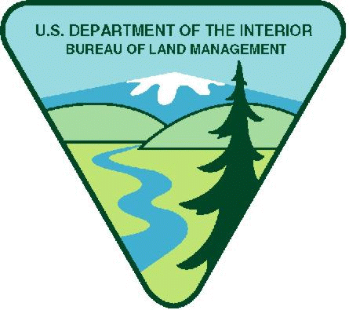
Project Title: Headquarters BLM Heritage and Paleontological Interns

Available Funding in FY26: $30,000.00
Maximum Funding (if multi-year): $400,000

Note: BLM has determined $800 weekly stipend equal to $20.00 per hour is reasonable. Stipends above this amount must justify in budget narrative increase needed.

Period of Performance: December 31, 2026 – December 30, 2028. Internships vary in length from 160 – 1,200 hours.

Project Background Information: The Bureau of Land Management (BLM) manages culturally, historically, and scientifically significant public lands across the United States, including cultural and paleontological sites, historic structures, traditional cultural properties, museum collections, and cultural landscapes. These resources support public education, scientific research, Tribal partnerships, and long‑term stewardship of America’s heritage.

This internship project supports national priorities by expanding opportunities for youth and emerging professionals to participate in cultural and paleontological resources management, archaeology, historic preservation, and heritage education. Interns will work alongside BLM specialists to assist with fieldwork, data collection, care of historical/significant collections, public outreach, and land management activities that protect and enhance cultural resources.

In alignment with Department‑wide workforce development and stewardship initiatives, this program provides hands‑on training, mentoring, and professional development. Interns will gain valuable experience in resource documentation, curation and collections management, resource protection, data management, and public engagement. The program is designed to advance agency priorities while helping participants develop transferable skills and increase competitiveness for future careers.
Project Objective: The objective of this internship opportunity is to provide youth with meaningful exposure to cultural and paleontological resource management on public lands while supporting BLM offices in meeting stewardship, planning, and public engagement needs. Interns will gain experience through hands‑on training in field and/or office environments, with mentorship from BLM resources staff who will guide them in understanding federal stewardship practices, documentation standards, and land‑management considerations.

Participating BLM sites will benefit from additional support in advancing cultural and paleontological resource initiatives, improving data quality, and strengthening public service and educational outreach. The presence of interns enhances the capacity of field offices to address stewardship priorities, engage communities and partners, and broaden awareness of heritage resources. The program fosters a mutually beneficial relationship in which interns gain valuable professional growth while BLM offices receive essential assistance in protecting and managing resources entrusted to their care.
The program also helps interns build broadly applicable skills – such as communication, research, teamwork, and project organization – that are transferable to a wide range of career paths in heritage preservation, land management, and related disciplines.

Work Schedule: Typically 40-hours per week; part-time work can occasionally be accommodated

Qualification Requirements: Applicants must also pass a DOI security background check.

Qualification requirements vary by internship. In general, applicants should possess educational background in cultural or paleontological resource management, historic preservation, archaeology, anthropology, paleontology, museum studies, or related discipline. Candidates must be willing to work in field and/or office settings and be able to follow guidance from BLM resources staff. Strong communication skills, attention to detail, and the ability to work both independently and as part of a team are essential.

Applicants should be comfortable learning new skills, using basic computer and organizational tools, and participating in projects that may involve outdoor conditions or routine administrative tasks. The ability to conduct oneself professionally in a federal agency environment is important, as interns may interact with the public, Tribal representatives, museum staff, volunteers, and partner organizations.

Selected interns must meet any onboarding requirements established by the Bureau of Land Management, which may include a background check, online training modules, or agency‑specific compliance procedures. Applicants must also meet any age or eligibility requirements set by the internship program or partner organizations.

Housing: Most internships include either housing or a housing allowance.

Vehicle Needs: Varies by internship

Other Project Considerations: Varies by internship

Duties: Interns may perform the following duties under the guidance of BLM cultural resource professionals:
- Conduct routine site monitoring to document conditions, identify potential impacts (such as natural deterioration, erosion, or vandalism), and assist with protective actions.
- Support archaeological, historical, or paleontological field surveys, including mapping, photography, feature documentation, and artifact or fossil recording following BLM standards.
- Assist with the cataloging, rehousing, and digitization of collections and archives using established curation procedures.
- Enter, review, and organize data in resources databases, GIS systems, spreadsheets, and archives.
- Help prepare public‑facing materials such as interpretive panels, social media content, educational resources, or volunteer training materials.
- Support outreach efforts, visitor engagement, and partnership activities, including collaboration with Tribal governments, historical societies, museums, local schools, and volunteer groups.
- Participate in resource stewardship projects such as site stabilization, landscape monitoring, cleanup activities, and heritage‑based resource management work.

BLM personnel will provide ongoing oversight, mentorship, and technical guidance to ensure interns receive meaningful, professional‑level experience and that work products meet agency standards.

BLM’s Involvement: There will be substantive BLM programmatic involvement by BLM professional to include mentoring, oversight, and engagement with youth participants as appropriate. BLM will have the right to intervene by modifying the project management plan, if project is not staying on schedule, technical issues arise, etc. In addition, BLM and recipient will meet weekly to discuss progress and track project outcomes; review any training needs; and then make a decision what direction to take in finalizing project or move to the next phase.

BLM Program Contact:

Field PO Name: Michael Brown

Field PO Phone Number: 480-714-6905

Field PO Email: mbrown@blm.gov

Applicants are encouraged to refer to the full program announcement number L26AS00064 posted on Grants.gov for all program requirements and applicable terms and conditions. Recipients selected for awards will be required to adhere to those requirements should an award be made.

