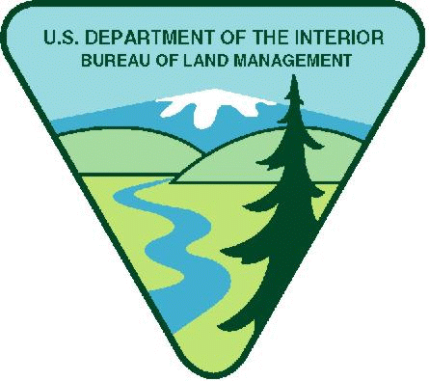
Project Title: Oregon: Coos Bay District Youth Opportunity

Available Funding in FY26: $48,000
Maximum Funding (if multi-year): $100,000

Note: BLM has determined $800 weekly stipend equal to $20.00 per hour is reasonable. Stipends above this amount must justify in budget narrative increase needed.

Period of performance: December 31, 2026- December 30, 2028

Project Background Information: Located within the Bureau of Land Management’s (BLM) Coos Bay District of southwestern Oregon, the project will operate across diverse landscapes in Coos and Curry Counties, encompassing forested streams, coastal marshlands, estuaries, and recreation corridors. These areas represent key ecological zones where restoration efforts can have lasting impact. The project supports BLM’s multiple-use management approach, which emphasizes sustainable forestry, recreation, and fish and wildlife habitat enhancement. By integrating youth into restoration activities, the program advances BLM’s goals of fostering environmental stewardship, building local workforce capacity, and engaging communities in the long-term care of public lands. This project aligns with the BLM's strategic priorities for 2026, including ecological restoration, youth engagement, and workforce development on public lands.
Project Objective: The primary project objectives of this youth agreement are to promote ecological restoration and youth development through the BLM’s Youth Program in Coos and Curry Counties. The youth crews will focus on implementing native plant revegetation projects and maintaining tree protection and fencing systems following watershed enhancement efforts. In addition to ecological restoration, the program should emphasize personal and professional growth by fostering teamwork, a strong work ethic, resume-building, interview preparation, and the development of both hard and soft skills.

Work Schedule: Monday – Friday, generally 8 AM to 5PM, with flexible start/end dates throughout the year, primarily during the summer months.

Qualification Requirements: Applicants must pass a DOI security background check.

Crew Leads and Program Managers should possess a minimum of a high school diploma and demonstrate a strong interest in natural resource management. Ideal candidates range from recent graduates in natural resource-related fields to individuals early in their careers, as well as those with non-traditional backgrounds who have gained relevant experience through work in agriculture, timber, or other land-based industries. The program Leads should demonstrate a willingness to learn, work collaboratively, and lead youth crews in outdoor, hands-on restoration and stewardship activities. Youth crew participants should be prepared to spend significant time outdoors, often working under moderately rigorous physical conditions in field environments. This opportunity will require time outdoors and field work that is often under somewhat rigorous physical conditions in varying weather conditions.

Much of the work is physical in nature, requiring bending, digging, and lifting. Hand tools and/or light power tools may be used.
Experience in habitat restoration, trail and recreation site maintenance, familiarity with invasive species removal and working with sensitive native plants is beneficial.

Housing: Camping at or near the project site is available. The BLM does not provide funding for camping or guarantee availability to local camp sites.

Vehicle Needs: Youth organizations will supply a van for transportation. A trailer may also be required to complete projects.

Other Project Considerations: Applicants should plan for the following:
- Food: The Youth Corps provides the meals for their crews.

- All Supplies: Youth Corps are responsible to purchase or provide tools such as hand tools, rakes, shovels, loppers, etc. In addition, the Youth Corps would supply tents and camping supplies to their crews and could include those costs in the budget narrative.

- Training Requirements: Youth Corps are responsible for all necessary training for crews, such as chainsaw training, first aid, computer training, crew leads training, individual training.

- Travel: The Youth Corps would include the cost associated with their projects travel to BLM sites in the budget narrative.

Duties: Participants in this youth program will engage in a variety of field-based and community stewardship activities that support ecological restoration and environmental education across both Coos and Curry Counties. Duties may include, but are not limited to:

- Planting and protecting native vegetation, including bare root plants and woody cuttings sourced, struck, and installed from native species.
- Maintaining restoration infrastructure, such as tree protection tubes and fencing systems on public and private lands.
- Controlling competing vegetation through mowing and weed whacking to support native plant establishment.
- Constructing and maintaining fences to protect restoration sites and sensitive habitats.
- Supporting community stewardship projects, such as ecological landscaping at urban rain gardens and assisting with school garden tasks like building raised beds and developing planting plans.
- Participating in educational site visits to watershed restoration areas to learn from natural resource professionals.
- Installing, operating, and maintaining field equipment, and assisting with biological monitoring tasks including spawning and juvenile fish surveys, fish weighing, measuring, and tagging.
- Harvesting, processing, and storing native seed, supporting native plant nursery operations, and contributing to revegetation monitoring and noxious weed management.

These responsibilities are designed to provide youth with meaningful, hands-on experience in natural resource management while fostering environmental stewardship, technical skill development, and career readiness.

BLM’s Involvement: There will be substantive BLM programmatic involvement by BLM professional to include mentoring, oversight, and engagement with youth participants as appropriate. BLM will have the right to intervene by modifying the project management plan, if project is not staying on schedule, technical issues arise, etc. In addition, BLM and recipient will meet weekly to discuss progress and track project outcomes; review any training needs; and then make a decision what direction to take in finalizing project or move to the next phase.

BLM Program Contact:

Field PO Name: Goldie Warncke

Field PO Phone Number: (541) 751-4283

Field PO Email: gwarncke@blm.gov

Applicants are encouraged to refer to the full program announcement number L26AS00064 posted on Grants.gov for all program requirements and applicable terms and conditions. Recipients selected for awards will be required to adhere to those requirements should an award be made.

