Information Collection: 0584-0512
Expiration date: 03/31/2029

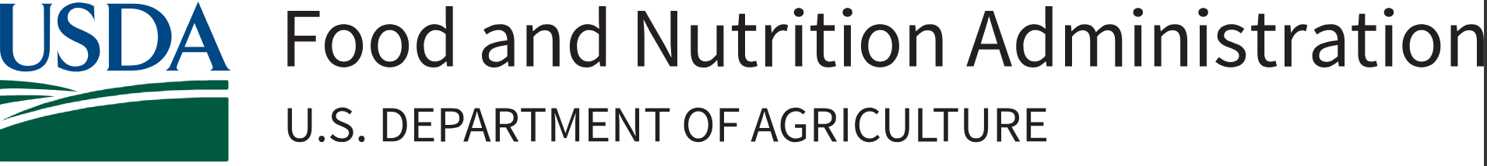

Food Distribution Program on Indian Reservations (FDPIR) Innovative Nutrition Education Cooperative Agreement Project

Fiscal Year 2026 Request for Applications (RFA)
Assistance Listing Number (ALN): 10.594

Release Date: | June 22, 2026
Application Due Date: | July 31, 2026; 11:59 pm, Eastern Daylight Time (EDT)
Anticipated Award Date: | September 2026
This information is being collected to assist the Food and Nutrition Administration (FNA) in collecting information from applicants needed to evaluate and rank applicants and protect the integrity of the cooperative agreement selection process. This is a voluntary collection and FNA will use the information received to evaluate proposed innovative nutrition education projects for the Food Distribution Program on Indian Reservations (FDPIR). This collection does not request any personally identifiable information under the Privacy Act of 1974. According to the Paperwork Reduction Act of 1995, an agency may not conduct or sponsor, and a person is not required to respond to, a collection of information unless it displays a valid Office of Management and Budget (OMB) control number. The valid OMB control number for this information collection is 0584-0512. The time required to complete this information collection is estimated to average 10 hours per response, including the time for reviewing instructions, searching existing data sources, gathering and maintaining the data needed, and completing and reviewing the collection of information. Send comments regarding this burden estimate or any other aspect of this collection of information, including suggestions for reducing this burden, to: U.S. Department of Agriculture, Food and Nutrition Administration, Office of Policy Support, 1320 Braddock Place, 5th Floor, Alexandria, VA 22314 ATTN: PRA (0584-0512). Do not return the completed form to this address.
Application Checklist

This Application Checklist provides applicants with a list of the required actions and documents that must be completed. However, FNA expects that applicants will read the entire RFA prior to the submission of their application and comply with all requirements outlined in the solicitation. The Application Checklist is for applicant use only and should not be submitted as part of the Application Package.

Complete the following at least four weeks prior to submission:
- Obtain a Unique Entity Identifier (UEI) number;
- Register the UEI number in the System for Award Management (SAM); and,
- Register in Grants.gov.

When preparing your application, ensure:
- Grant application narrative and format meet the requirements included in Section 4 – Application Content Information. This includes page limits, priorities outlined in Section 5 – Application Review Information, and all necessary attachments.

When preparing your budget, ensure the following information is included:
- Budget narrative with key details outlined in Section 4 – Application Content Information. This includes page limits and priorities outlined in Section 5 – Application Review Information, and all necessary attachments.
- All key staff proposed to be paid by this grant.
- The percentage of time the Project Director will devote to the project in full-time equivalents (FTEs).
- Your organization’s fringe benefit rate and amount, as well as the basis for the computation.
- The type of fringe benefits to be covered with Federal funds.
- Itemized travel expenses (including type of travel), travel justification, and basis for lodging estimate.
- Types of equipment and supplies, justifications, and estimates, ensuring that the budget aligns with the project description.
- Information for all contracts and justification for any sole-source contracts.
- Justification, description, and an itemized list of all consultant services.
- Indirect cost information. Provide either a copy of a Negotiated Indirect Cost Rate Agreement (NICRA) or if no agreement exists, the applicant may charge up to 15% de minimis. If an applicant is requesting the de minimis rate or indirect costs are not required, please state this in the budget narrative.
- NICRA (PDF - Upload using the “Add Attachments” button under SF-424 item).

When submitting your application, ensure you have submitted the following:
- SF-424 – Application for Federal Assistance (fillable PDF in Grants.gov)
- SF-424A – Budget Information and Instruction Form (fillable PDF in Grants.gov)
- SF-424B – Assurances for Non-Construction Programs (fillable PDF in Grants.gov)
- SF-LLL – Disclosure of Lobbying Activities
- FNS-906 – Grant Program Accounting System & Financial Capability Questionnaire (fillable PDF in Grants.gov)
- Negotiated Indirect Cost Rate Agreement
- Nonprofit organizations must include their 501(c)(3) determination letter issued by the Internal Revenue Service (IRS). If any other nonprofit status applies, i.e., 501(c)(4) please describe and document your current status (upload if applicable)
- Application Project Summary
- Program Narrative-including Cover sheet as first page
- Budget Narrative and Line-item budget
- Documentation demonstrating experience in providing FDPIR-related nutrition education, food safety education/training, or food service-related training to ITOs and State agencies that administer FDPIR (see section 3 – Eligibility Information)
- Cover letter and work product (1 required)
- Letters of Support (2 required)
- Resumes of Key Project Staff

- Additional attachments as required.

Table of Contents
1. Program Description and Objectives 6
Key Objectives 8
Cooperative Agreement Terms 8
2. Federal Award Information 10
Allowable Costs 11
Unallowable Costs 12
3. Eligibility Information 13
Eligible Applicants 13
Cost Sharing or Matching Considerations 15
Pre-Award Screening Requirements 15
Acknowledgment of USDA Support 15
4. Application Content Information 15
Content and Form of Application Submission 15
Special Instructions: 16
Cover Page 16
Table of Contents 16
Application Project Summary 16
Project Narrative 16
Activities/Indicators Tracker 17
Application Budget Narrative 20
Indirect Cost Rate 20
Required Grant Application Forms 21
5. Application Review Information 21
Review Criteria 21
Project Design and Implementation (25 points) 22
Evaluation Component (10 points) 22
Staff Experience, Management, and Partner Capability (25 points) 23
Organizational Experience and Past Performance (25 points) 23
Budget Appropriateness (15 points) 23
Bonus Points (up to 20 points) 24
Review and Selection Process 24
6. Application Submission Information 24
Submission Date 24
Preparing for Electronic Application Submission through Grants.gov 25
How to Submit an Application via Grants.gov 26
Grants.gov Receipt Requirements and Proof of Timely Submission 26
Intergovernmental Review 27
Funding Restrictions 27
7. Federal Award Administration Information 27
Federal Award Notice 27
Administrative and National Policy Requirements 27
Confidentiality of an Application 27
Conflict of Interest and Confidentiality of the Review Process 28
Administrative Regulations 28
Code of Federal Regulations and Other Government Requirements 31
Reporting Requirements 31
Financial Reports 31
Performance Progress Reports (PPR) 32
8. Federal Awarding Agency Contacts 32
9. Other Information 32
Debriefing Requests 32
Appendix 33
RFA Budget Narrative Checklist 33
FNS-908 Performance Progress Report (PPR) 35

1. Program Description and Objectives
Legislative Authority
The Food Distribution Program on Indian Reservations, is authorized under Section 4(b) of the Food and Nutrition Act of 2008 (as amended in the Agriculture Improvement Act of 2018, P.L. 115-334). Through the Continuing Appropriations, Agriculture, Legislative Branch, Military Construction and Veterans Affairs, and Extensions Act, 2026 (Public Law 119-37), Congress provided FNA with $998,000 for nutrition education in FDPIR. FNA will award this cooperative agreement under USDA’s general authority to enter into contracts, grants, and cooperative agreements in accordance with section 1472 of the National Agricultural Research, Extension, and Teaching Policy Act of 1977 (7 U.S.C. 3318). 7 CFR 2.19(a)(3) delegates this authority to the Undersecretary for Food, Nutrition, and Consumer Services for purposes of activities related to human nutrition information.

Executive Summary
The USDA’s Food and Nutrition Administration (FNA) works to nourish those in need through financially sound programs that promote health and work, as well as champion the productivity of American agriculture. USDA FNA seeks to enter into a cooperative agreement(s) with an organization(s)/agency(ies) with expertise in working with Tribal communities who can develop, design, and implement an innovative nutrition education project for participants and program staff of the FDPIR. A maximum of $500,000 will be made available for this opportunity for the period of performance from September 2026 to September 2028. The goal for this project is to develop and deliver an innovative nutrition education project. This project will provide participants receiving benefits and services from Indian Tribal Organizations (ITOs) and State agencies that administer FDPIR with culturally appropriate nutrition education activities and programming that promote USDA Foods and support Secretary Brooke Rollins’ priority to strengthen strategies that encourage healthy choices, healthy outcomes, and healthy families. The tools and resources developed under this cooperative agreement must align with the Dietary Guidelines for Americans, 2025 – 2030 (Dietary Guidelines) and support the efforts of FDPIR program staff in conducting nutrition education activities for FDPIR participants who receive USDA Foods.

Eligible applicants are ITOs and State agencies that administer FDPIR, nonprofit or private organizations, accredited public or private academic institution of higher education including Tribal colleges and universities, and eligible Tribal entities as defined in 25 U.S.C. § 5304 or a national Tribal organization. Please read the RFA thoroughly for full eligibility requirements, available in Section 3.

The FY 2026 FDPIR Nutrition Education Cooperative Agreement opportunity will fund up to two projects for 24 months (2 years). Award amounts will range from a minimum of $100,000 to a maximum of $500,000.

Background
FDPIR is one of the 16 nutrition assistance programs administered by USDA FNA. FDPIR provides 100% American grown and produced foods, called USDA Foods, to eligible households (participants) living on Indian reservations, and to American Indian households residing in approved areas near reservations or in Oklahoma. USDA Foods support American farmers and provides safe, high quality, real food, to Tribal communities.

Many households participate in FDPIR as an alternative to the Supplemental Nutrition Assistance Program (SNAP), because they do not have easy access to SNAP offices or authorized food stores. The program is administered locally by either ITOs or a State agency. Currently, there are approximately 280 tribes administering FDPIR and providing USDA Foods and nutrition education to participants through 107 ITOs and three State agencies. FDPIR provides nutritious, 100% American grown, real food, to around 68,000 participants in Federal Fiscal Year 2026.

FNA selects USDA Foods for the FDPIR food package based on their alignment with recommendations in the latest Dietary Guidelines and in consultation with the FDPIR Food Package Review Workgroup (Workgroup). FNA convenes the Workgroup, which includes experts on American Indian/Alaskan Native health and nutrition issues, FDPIR participant food preferences, and the Federal procurement and delivery process of USDA Foods. These experts include Federal and Tribal health professionals, National Association of Food Distribution Programs on Indian Reservation (NAFDPIR) officials, and other representatives from ITOs and State agencies that administer FDPIR. The Workgroup meets regularly to review the FDPIR food package and consider revisions that help the food package better meet the nutritional needs and food preferences of program participants.

Nutrition education is a key component and requirement for ITOs and State agencies administering FDPIR. The goal is to improve the likelihood that households eligible for FDPIR will make healthy food choices consistent with the Dietary Guidelines. Nutrition education services are a combination of educational strategies and learning experiences, accompanied by supporting policy, systems, and environmental interventions, designed to facilitate the voluntary adoption of food choices and other nutrition-related behaviors conducive to the health and well-being of participants. FNA currently offers nutrition education opportunities for FDPIR program participants and program operators/staff:

- FDPIR Sharing Gallery – A repository of resources and materials to assist ITOs and State agencies who administer FDPIR in providing food and nutrition information to program participants. Resources include recipes, cookbooks, handouts, photos, and toolkits. Most resources were developed by Tribal communities. For more information about the FDPIR Sharing Gallery, visit https://www.fns.usda.gov/fdpir/sharing-gallery.
- USDA Foods Nutrition Education Resource Library – A digital library of program specific, nutrition education resources for ITOs and State agencies administering FDPIR. Administering agencies can order a variety of resources for free that are shipped directly to them. Resources include posters, recipe cards, magnets, shelf-talkers, stickers, and brochures. For more information about the USDA Foods Nutrition Education Resource Library, visit https://orders.gpo.gov/USDAFSND/Pubs.aspx.
- Community Nutrition Champion Training (CNCT) – A nutrition paraprofessional training program for FDPIR program operators and staff. CNCT is a multicomponent training initiative aimed at empowering FDPIR staff to be nutrition champions in their communities. CNCT 1.0 is a two-day, interactive in-person training that teaches non-nutrition professionals basic nutrition information about USDA Foods through written coursework, storytelling, cooking demonstrations, and facilitated discussion. CNCT 2.0 is a three-day immersive nutrition education training program that builds on nutrition knowledge gained in CNCT 1.0 and highlights local engagement and nutrition outreach opportunities that help build community partnerships and strengthen healthy outcomes.
- FDPIR Produce Training – A two-day training designed to teach FDPIR program operators and staff how to properly and safely receive and distribute fresh produce to program participants.

The cooperator(s) under this project will develop and deliver an innovative nutrition education project that advances the promotion of USDA Foods and supports healthy choices and positive nutrition outcomes. All tools, materials, and resources produced under this cooperative agreement must align with the Dietary Guidelines and enhance, rather than duplicate, existing FDPIR nutrition education offerings.

The cooperator is required to design a new, distinct, and original nutrition education project that supplements current FDPIR resources and can be readily integrated into existing nutrition education programming. The proposed project must address identified gaps in current nutrition education activities and provide meaningful added value to FDPIR participants.

The project may include the development and dissemination of culturally relevant nutrition education and training materials such as posters, pamphlets, calendars, newsletters, signage, curriculum, webinars, recipe cards, window clings, other point-of-decision signage and behavioral cues, etc.) that support USDA Foods available in the FDPIR food package including fresh produce available through the USDA Department of Defense Fresh Fruit and Vegetable Program (USDA DoD Fresh).

Key Objectives
Below is a list of the Program Objectives. As noted in Section 4, within the “Activities/Indicators Tracker,” proposed activities should be clearly aligned to these objectives and their associated activities and indicators.

Application proposals must include both required objectives (1 & 2) identified in the chart below. Funding requested should align with the scope of the project and must support nutrition education for all ITOs and State agencies administering FDPIR. Applications that only support nutrition education activities for a specific region or for a limited number of ITOs or State agencies will not be considered.

Note that if awarded, cooperators will be required to report on progress toward activities aligned with the required objectives and must use the FNS-908 Performance Progress Report. Carefully considering proposed activities and indicators will prepare cooperators for their progress reporting requirements if awarded.

# | Objective
1 | (REQUIRED) Develop, implement, and promote culturally appropriate food and nutrition programming and/or resources directly to FDPIR participants that encourage consumption of USDA Foods and align with the latest Dietary Guidelines.
2 | (REQUIRED) Facilitate and strengthen partnerships to provide sustainable nutrition education, food safety, and wellness promotion programs in Tribal communities.

Cooperative Agreement Terms
In the context of this cooperative agreement, nutrition education should focus on how USDA Foods in the FDPIR food package may be used to contribute to a healthy diet and support healthy outcomes. The cooperator(s) shall work with appropriate organizations and partners as needed, such as extension agents, Tribal colleges and universities, registered dietitians, diabetes educators, and public health nutrition professionals with experience working with Tribal communities in FDPIR.

Required deliverables for this cooperative agreement include:
- Comprehensive report for FNA that will inform development of the required deliverables carried out through the project workplan.
  - To inform this report, the cooperator must collect and analyze information on the nutrition education needs of FDPIR participants and identify opportunities to better support FDPIR program operators and staff in delivering nutrition education.
- Culturally relevant nutrition education resources for FDPIR participants that promote USDA Foods and the Dietary Guidelines.
  - Materials must align with identified needs and promote practical, sustainable, application within the FDPIR setting.
- Comprehensive evaluation report that describes the reach and implementation of nutrition education resources and training opportunities.
  - If training opportunities are implemented, outcome measures of trainee’s knowledge, skills, attitudes, and behaviors pre and post exposure to initial training are required in the report.
- At least one (1) coordinated nutrition education engagement that convenes Tribal nutrition professionals and paraprofessionals supporting nutrition education efforts in FDPIR.
- Culturally relevant nutrition education training curriculum or ‘turnkey’ resources for FDPIR program operators that enhance knowledge, skill, and capacity to conduct nutrition education activities.
  - Materials must align with identified needs and promote practical, sustainable, application within the FDPIR setting.
Cooperator Responsibilities: The recipient of this cooperative agreement is expected to work collaboratively with FNA through the planning, development, implementation, and evaluation phases of this innovative nutrition education initiative. Specifically, the cooperator will be required to:
- Develop and implement all applicable tools, resources, materials, and programs that will address the specific needs of FDPIR participants, program operators, and/or staff, with input from FNA.
- Support nutrition education efforts across all participating ITOs and State agencies that administer FDPIR.
- Determine project and/or training initiative implementation (format/delivery mechanism) to address the specific needs of the audience, with input from FNA.
- Execute the nutrition initiative as specified in the project requirements with input from FNA.
- Promote the project to the intended audience and/or to help recruit and identify trainees.
- Manage and monitor the progress of the cooperative agreement project activities and report on progress to FNA using an agreed upon timeframe.
- Manage the cooperative agreement budget.
- Manage cooperative agreement staff and/or consultants.
- Develop and implement easy to use evaluation methods that participants will use to assess the project/initiative and its intended objectives and outcomes. FNA expects to collect this evaluation data in the comprehensive evaluation report.
- Evaluate participant and/or trainee knowledge, skills, attitudes, and behaviors before and after exposure to project/initiative activities.
  - Non-traditional evaluation methods may be recommended by the cooperator. It is important to use methods that are appropriate and culturally relevant to American Indian and Alaskan Native audiences.
- Share evaluation results with FNA using an agreed upon timeframe and determine what improvements can be made.
- Coordinate outreach and disseminate information to ITOs and State agencies that promote the innovative nutrition education project.
- Perform occasional travel as related to specific meetings and nutrition programming-related activities needed to execute the project.
- Meet with FNA staff by participating in monthly conference calls or more frequently as needed during the duration of the performance period to provide project updates. Additional conference calls may be scheduled as needed.

FNA Responsibilities: Substantive involvement by FNA is inherent in the cooperative agreement award. At a minimum, FNA will provide oversight in developing applicable tools, resources, materials, and programs for the innovative nutrition education initiative. Specifically, FNA will:
- Provide oversight of the planning, implementation, and monitoring process proposed by the cooperator.
- Review and approve deliverables of the innovative nutrition education project through the duration of the project.
- Review and approve curricula, resources, evaluations, reports, and the format/delivery mechanisms of the nutrition education initiative.
- Initiate progress meetings to discuss accomplishments, difficulties, assistance needed from FNA on technical issues, and major planned activities.
- Approve implementation strategies and consult with the cooperator to finalize the process.
- Amplify the nutrition education resources and training opportunities the cooperator develops.
- Discuss evaluation results with the cooperator at the conclusion of each implemented activity/project.

2. Federal Award Information
The following information is intended to provide applicants with information to help make informed decisions about proposal submissions.

- Total amount of funding expected to award: $500,000
- Anticipated number of awards: up to 2
- Minimum award amount (award floor): $100,000
- Maximum award amount (award ceiling): $500,000
- Anticipated award announcement date: September 2026
- Anticipated period of performance (start and end date of the award): September 2026 – September 2028
- Application due date: July 31, 2026

Please note:
- Grant awards are subject to the availability of funding and/or appropriations of funds.
- FNA reserves the right to use this solicitation and the results of this competition to award additional grants this year or the subsequent fiscal year, should additional funds become available.
- Applications, and all proposed activities, must comply with applicable laws, regulations, and executive orders. FNA reserves the right to exclude from consideration any applications proposing activities in contradiction of these requirements.
- The submission of an application does not guarantee funding. Applications will be scored and selections will be made based on the competitive evaluation criteria in Section 5 – Application Review Information.

Allowable Costs
Personnel Costs and Fringe Benefits
Salaries and fringe benefits of personnel involved in nutrition education resource development, training, and administrative support of activities under this cooperative agreement, including contracted employee salaries.
- All staff wages, salaries, and fringe benefits must be computed on a reasonable hourly basis commensurate with duties being performed.
- The wages and salaries must be commensurate to the task an individual is performing under this cooperative agreement, as opposed to reflecting other positions for which they are credentialed (i.e., if a physician leads a nutrition education training for teachers, pay must be commensurate with the activity of nutrition education training rather than that of a physician).

Evaluation
All proposals should include an evaluation component. Costs associated with evaluation activities are allowed. The evaluation methods and measurement tools in the proposal must be appropriate for the grant objective and associated activities.

Subcontracts
Recipients must obtain written approval from the USDA awarding agency prior to issuing subawards or contracts (including any similar forms of agreement) regarding any segment of a funded award. Requests for prior approval must be in writing and identify the subrecipient or contractor, authorized activities, and all anticipated costs. If all such elements are identified in a budget or budget narrative at time of application, approval of the award constitutes prior written approval of the subaward or contract.

Travel
Reimbursement for travel and lodging costs for key project staff to attend trainings and activities related to the grant is allowable. A clear oversight process must be in place to ensure the appropriate use of funds according to established travel allowances.

Travel expenses may only be incurred for activities which directly support the implementation of this cooperative agreement. Examples of potential travel include travel costs to and from proposed training activities or planned meetings/conferences for FDPIR nutrition professionals and paraprofessionals.

Equipment and Supplies
Expenditures for equipment (i.e., items of personal property having a useful life of more than one year and a cost of $10,000 or more) are allowable expenses with prior approval by FNA. FNA reserves the right to approve/disapprove these expenditures based on needs as expressed by the proposed project. Supplies do not require a separate specific prior approval outside of the budget/proposal approval process, but they must be included in the budget narrative and support the creation and dissemination of culturally relevant nutrition education materials.

Nutrition Education Reinforcement Materials
Nutrition education reinforcement materials refer to any material distributed for involvement/ participation in a nutrition education activity such as stickers, buttons, or refrigerator magnets.

Any cost associated with nutrition education reinforcement materials must be reasonable in comparison to the grant funding. Nutrition education reinforcement materials should:
- Be included in the budget narrative and have a clear, relevant, and useful connection to the nutrition education or training activity they are intending to reinforce.
- Contain a nutrition education message that is directly related to the FDPIR food package and consistent with the Dietary Guidelines.
- Be offered only after weighing and assessing other relative needs and cost effectiveness.
- Be reasonable, necessary, and non-food items.
- Cost $7.00 or less per unit.
- Not exceed 10 percent of the budget.

Promotional Items
The purchase of promotional items is allowed if they are directly related to the grant proposal’s objective, and the need must be clearly described in the grant application and budget narrative. Any costs associated with such promotions must be reasonable in comparison to the grant funding. Individual items may not exceed a per unit cost of $5.00 and in total, promotional items may not exceed more than 10 percent of the budget.

Food
No more than 10 percent of the funds may be used for food purchases, and the use must be clearly delineated in the grant budget. Allowable expenses of food include food and ingredients which may be purchased to develop, evaluate, and disseminate recipes utilizing USDA Foods found in the FDPIR food package. Food purchases must be limited to educational and training purposes only, such as taste tests. Food costs related to offering a sample of a nutritious recipe developed through this cooperative agreement are deemed an appropriate use of funds. Food purchases must be clearly identified within the submitted budget narrative.

Unallowable Costs
Pre-award Costs
Pre-award costs will not be permitted for this grant project.

Gift Cards
Gift cards are not an allowable expense under this grant opportunity. For the purposes of this grant opportunity, “gift cards” refers to any token, voucher, ticket, certificate, or other item with cash value that serves as a substitute for cash.

Meals or Snacks for Training or Meeting Attendees
Meals and snacks for training or meeting attendees are not an allowable expense under this grant opportunity.

Advertising and Public Relations
Advertising costs and other promotional costs associated with advertising and public relations are unallowable. The term “advertising costs” means the costs of advertising media and corollary administrative costs. Advertising media include magazines, newspapers, radio and television, direct mail, exhibits, and electronic or computer transmittals (2 CFR 200.421 Advertising and Public Relations).

All costs proposed in the budget and detailed in the budget narrative must be allowable, reasonable, necessary, and allocable. Refer to 2 CFR Part 200 Subpart E – Cost Principles for a detailed description of all allowable and unallowable costs. A complete listing of selected items of costs is located at 2 CFR 200.420 – 200.476. The provisions of 2 CFR 200 Subpart E allow FNA to make reasonable judgments as to what is necessary and reasonable to be approved for funding in a project proposal.

3. Eligibility Information

Eligible Applicants
Entities that do not meet the eligibility definitions will be deemed ineligible and removed from competition without further consideration. In order to be eligible for this grant, applicants must be one of the eligible entities listed below and must demonstrate experience in providing FDPIR-related nutrition education, food safety education/training, or food service-related training to ITOs and State agencies who administer FDPIR during the three-year period preceding the submission of a proposal for this cooperative agreement. Applicants are required to submit documentary evidence of work detailed in the Demonstrated Experience section below or they will be deemed ineligible.

The following are eligible entities:

- An ITO or State agency that administers FDPIR.
- A nonprofit or private organization:
  - All nonprofit organizations must include their 501(c)(3) determination letter issued by the IRS. If any other nonprofit status applies, i.e., 501(c)(4), please describe here.
- An accredited public or private academic institution of higher education including Tribal colleges and universities (as defined in 20 U.S.C. §1001).
- An Eligible Tribal entity as defined in 25 U.S.C. § 5304 or a national Tribal organization.

Eligible applicants may apply individually or as a consortium (i.e., coalition of community-based organizations or a regional nutrition advisory council). However, if one or more eligible applicants wish to apply as a consortium, one organization/agency must be designated as the lead agency and apply on behalf of the other organization(s)/agency(ies). The lead agency is fiscally and operationally responsible for the project, providing oversight and fulfilling all reporting requirements for its overall administration as detailed in Cooperators Responsibilities in Section 1 – Program Description and Objectives – Cooperative Agreement Terms on pages 9 - 10. FNA will accept only one application from each organization/agency or consortium in response to this solicitation.

Demonstrated Experience Documentation (required)
Documentation demonstrating experience in providing FDPIR-related nutrition education, food safety education/training, or food service-related training to ITOs and State agencies that administer FDPIR (see section X) during the three-year period (no later than August 2023) preceding the submission of a proposal for this cooperative agreement. Applicants are required to submit all of the following documentary evidence of work (1 – 3) or they will be deemed ineligible:

  - Applicant’s experience described in a detailed cover letter:
    - Describe related experience captured on no more than two (2) pages.
    - Include at least one (1) work product from past projects within the last three years. An example of a work product is a project the applicant successfully completed with similar deliverables. Be sure to use the term “work product” in your cover letter.
  - Two (2) letters of support from clients with experience working directly with the applicant. Each letter of support must detail the nutrition-related project/service the applicant completed for them, the associated outcomes, and a formal endorsement of the applicant’s capability to successfully implement the proposed project in Tribal communities.
  - Key Project Staff Experience:
    - A curriculum vitae (resume) for all key project staff individuals, for the proposed project.

Note: Failure to submit items 1, 2, and 3 (under Demonstrated Experience Documentation) will eliminate an applicant from consideration of this RFA. All demonstrated experience must be submitted with your application on grants.gov. No documentary evidence of work will be accepted outside of grants.gov.

Ineligible Applicants
Entities not meeting the eligibility requirements listed above are not eligible to apply and include:
- International (non-U.S. or non-U.S. territories) entities.
- Child care facilities, K-12 schools and school districts.

NOTE: In cases where an applicant is deemed nonresponsive for failing to submit required elements or documents associated with this RFA, they will be considered ineligible and removed from consideration.

IN ADDITION: Those applicants who fail to submit any required documents or forms will be deemed NONRESPONSIVE and therefore will be INELIGIBLE to participate in the competition and removed from further consideration.

Cost Sharing or Matching Considerations
- There are no cost sharing or matching requirements for this award.

Pre-Award Screening Requirements
In reviewing applications in any discretionary grant competition, prior to making a Federal award, Federal awarding agencies, in accordance with 2 CFR 200.206, are required to review information available through any OMB-designated repositories of governmentwide eligibility qualifications or financial integrity information. Additionally, Federal awarding agencies are required to have a framework in place for evaluating the risks posed by applicants before they receive Federal awards. The FNA review of risk posed by applicants will be based on the following:
- SAM.gov, the System for Award Management, the Official U.S. Government system that consolidated the capabilities of CCR/FedReg, ORCA, EPLS, and Federal Awardee Performance and Integrity Information System (FAPIIS).
- FNA Risk Assessment Questionnaire (FNS-906).
  - Applicants must complete the Grant Program Accounting System & Financial Capability Questionnaire that allows FNA to evaluate aspects of the applicant’s financial stability, quality of management systems, and history of performance, reports, and findings from audits. The questionnaire contains a number of questions that may be an indicator of potential risk.

The evaluation of the information obtained from the designated systems and the risk assessment questionnaire may result in FNA imposing special conditions or additional oversight requirements that correspond to the degree of risk assessed.

Acknowledgment of USDA Support
- As required in 2 CFR 415.2, the recipient must have an acknowledgment of the USDA awarding agency support placed on any information dissemination products with any Federal financial assistance support, including those which report the results of, or describe, a Federal financial assistance-supported activity. Grant recipients may be asked to host USDA officials for a site visit during the course of their grant award. All costs associated with the site visit will be paid for by USDA and are not expected to be included in grant budgets.

4. Application Content Information

Content and Form of Application Submission
FNA strongly encourages eligible applicants interested in applying to this program to adhere to the following applicant format. The proposed project plan should be presented on 8 ½” x 11” white paper with at least 1-inch margins on the top and bottom. All pages should be single-spaced in 12-point font. The project description with relevant information should be captured on no more than 15 pages, not including the cover sheet, table of content, resumes, letter(s) of support, endorsement letter(s), budget narrative(s), appendixes, and required forms. All pages, excluding form pages, must be numbered.

Special Instructions:
- Late application submission will not be considered in this competition. FNA will not consider additions or revisions to applications unless they are submitted via Grants.gov by the deadline. No additions or revisions will be accepted after the deadline.
- Letters of support or Letters of commitment must be submitted with the application through Grants.gov. Letters submitted separately or via email will not be considered.
- Applications submitted without the required supporting documents, forms, certification will not be considered.
- Applications missing a written proposal or budget narrative will not be considered and deemed nonresponsive and removed from further consideration.
- FNA reserves the right to request clarification on any application submitted in response to this solicitation.
- Applications not submitted via Grants.gov will not be considered.
- If multiple application packages are submitted through Grants.gov by the same applicant in response to this solicitation, FNA will accept the latest application package successfully submitted. All other packages submitted by the applicant will be removed from this competition.

Cover Page
The cover page should include, at a minimum:
- Applicant’s name (must match the Legal name in the SF-424, Box 8a.) and mailing address
- Primary contact’s name, job title, mailing address, phone number, and email address
- Grant program title and subprogram title (if applicable)
- Indicate the applicant’s eligibility category their organization represents (i.e. Indian Tribal Organization, nonprofit). See eligible entities list for reference.

Table of Contents
The Table of Contents should include relevant sections, subsections, and associated page numbers.

Application Project Summary
The application should clearly describe the proposed project activities and anticipated outcomes that would result if the proposal were to be funded.

Project Narrative

NOTE: Nutrition education is a key component and requirement for ITOs and State agencies administering FDPIR. The goal is to improve the likelihood that households eligible for FDPIR will make healthy food choices consistent with the Dietary Guidelines.

The project narrative should clearly identify what the applicant is proposing, including a detailed narrative that presents a clear plan outlining the specific activities that will be completed. It should explain how the proposed project addresses a solution, the expected results and/or benefits once the solution is achieved, and how it will meet the RFA program scope and required objectives. The proposed project methodology should describe the project design, address program specific methodology needs, procedures, timetables, monitoring/oversight, and the organization’s project staffing.

The project narrative should serve as a comprehensive and well-defined project plan that clearly outlines how the proposed activities will address nutrition education needs in FDPIR, demonstrating how the approach aligns with program objectives and supports meaningful, measurable outcomes.

Applicants must submit a project narrative that includes the sections in the order they appear below. The project narrative must not exceed 15 pages in total. The project narrative must be formatted to fit on an 8.5 x 11-inch page, may be landscape or portrait orientation, using a clearly legible font no smaller than 11-point. Using 10-point font in tables is acceptable.

The applicant should save their project narrative as one document, save it as a PDF, and attach it to the Grants.gov application package using the “Add Attachments” button under SF-424 item.

Activities/Indicators Tracker
Proposed activities and indicators measuring success must be mapped to both required program objectives (as described in Section 1 – Program Description and Objectives). Use the chart format below to describe the activities and indicators that will be used to measure success. Include additional activities and indicators based on the proposed project.

Note: Indicators are defined as any metric that can be tracked during the grant’s period of performance. Common examples include Number of People Attended, Number of People Impacted, Number of Conferences Delivered, Number of Materials Created, Number of Trainings, and Number of People Trained.

The Activities/Indicators Tracker must contain the following columns, clearly labeled in the following order:
- Objective
- Activity
- Indicators and Target Number
- Anticipated Start Date and End date (Month, Year)

The chart below is an example of how this information should be presented. Applicants must use this chart format to detail their proposed activities, indicators, targets, and timeline. Applicants should not just copy the example below and submit it as their proposal. The information in the example below that should be the same in the applicant’s Activities/Indicator chart are the headers and the required objectives. The activities, indicators, targets, and timeline should reflect the applicant’s proposed project.

Objective  (REQUIRED) | Activity | Indicators and Targets | Anticipated Start and End Dates
OBJ #1: Develop, implement, and promote culturally appropriate food and nutrition programming and/or resources directly to FDPIR participants that encourage consumption of USDA Foods and align with the latest Dietary Guidelines for Americans. | Create and disseminate culturally relevant nutrition education resources (e.g., posters, handouts, videos, cookbooks, recipe cards) that support participants in applying recommendations from the Dietary Guidelines, including:  - Prioritize high quality, nutrient-dense protein from both animal and plant sources.  - Select a wide variety of whole, colorful, nutrient-dense vegetables and fruits in their original form. Prioritize freshness and minimal processing.  - Avoid highly processed packaged, prepared, ready-to-eat foods. | Indicators:  - Number of resources developed  - Number of different types of resources developed  - Method(s) of dissemination  Target:  - Develop 5 types of resources  - Use three unique methods to disseminate resources | October 2026 through June 2028
OBJ #1: Develop, implement, and promote culturally appropriate food and nutrition programming and/or resources directly to FDPIR participants that encourage consumption of USDA Foods and align with the latest Dietary Guidelines for Americans. | Provide sustainable nutrition education and wellness promotion programs by developing easily adoptable (“turnkey”) lesson materials, videos, cookbooks, and/or training curriculum, which are readily available for FDPIR operators and staff to use as a form of nutrition education for FDPIR participants. | Indicators:  - Number of training resources developed  - Number of FDPIR staff trained or provided with resources  - Number of sites distributing resources  Target:  - Develop 5 training resources  - Train 20 FDPIR staff with resources at 10 program sites | October 2026 through June 2028
OBJ #2: Facilitate and strengthen partnerships to provide sustainable nutrition education, food safety, and wellness promotion programs in Tribal communities. | Convene Tribal nutrition professionals, paraprofessionals, and individuals engaged or interested in FDPIR nutrition education to share existing tools, resources, and innovative approaches for developing and delivering culturally appropriate nutrition education to eligible FDPIR participants. | Indicators:  - Number of events held  - Number of partners engaged in FDPIR nutrition education  Target:  - Convene 10 events  - Engage five new partners | September 2026 to March 2028

Key Project Staff
List key project staff, including applicant personnel and external partners that comprise the project team. Include sufficient information to demonstrate the key staff have the ability to complete the project and the relevant experience in developing and implementing the proposed project. Include a brief description (approximately three sentences each) of the role, relevant experience, and past successes of key project staff. If a key project staff position has not been filled, include the position title and briefly describe the desired knowledge, skills, and education required to fulfill this position.

Provide this information in a table with the following column headings:
- Name and Title
- Organization
- FTE Dedicated to the Project
- Role
- Relevant Experience

Project Management
Describe how the key project staff will ensure the project is successful and complies with requirements. Include quality assurance planning, tracking timelines, progress monitoring, and management approach for staffing and procurement of contractors (if applicable).
If an applicant proposes to use grant funding to award subgrants, the applicant must include a description of the process for making and managing subgrant awards, including reporting and compliance. The recommended length of this response is 125 words.

Evaluation
Evaluation Description
Describe how the overall impact of the project will be evaluated and the evaluation activities you will conduct to meaningfully measure your program. Describe how the indicators will be collected to ensure successful measurement and reporting. All indicators included in the Activities/Indicator chart must be specific, measurable, achievable, relevant, and time bound, and are associated with a specific activity. The recommended length of this response is 125 words.

Evaluation Roles
Describe roles and responsibilities for monitoring and evaluation activities. Detail any relevant experience your organization and project partners have conducting evaluations. The recommended length of this response is 125 words.

Demonstrated Experience
Cover Letter
The cover letter must describe the applicant’s related experience providing nutrition education in Tribal communities on no more than two (2) pages. The applicant must reference and include at least one (1) work product from past projects within the last three years in the cover letter. An example of a work product is a project with similar deliverables the applicant has successfully completed. Be sure to use the term “work product” when explaining how it demonstrates your experience in the cover letter. The cover letter and example of at least one work product are required and must be submitted as an attachment. The attached work product is not subject to the cover letter’s two-page limit.

Letters of Support
At least two (2) letters of support are required from clients with experience working directly with the applicant. Each letter of support must detail:
- A nutrition-related project/service the applicant completed for the client.
- Associated outcomes of the nutrition-related project.
- A formal endorsement of the applicant’s capability to successfully implement the proposed nutrition education related project in Tribal communities.

Each letter of support must not exceed two (2) pages in length. Any additional letters over the two-letter limit will not be considered.

Letters of support are a separate and distinct requirement from the cover letter. FNA does not require Congressional letters of support, and such letters do not carry additional weight during the evaluation process. Congressional letters of support submitted outside of Grants.gov will not be included as a component of the applicant’s official submission and will not be considered during the panel review.

Key Project Staff Curriculum Vitae (Resumes)
Applicants must submit resumes for key project staff noted in the Project Staff section of the project narrative. Any additional resumes will not be considered. Resumes should be no longer than two (2) pages each. Any additional pages after the second page will not be reviewed. If a key project staff position has not been filled, include the position title and job description, which includes a brief description of the desired knowledge, skills, and education required, on no more than one (1) page in the application in lieu of a resume.

The (1) cover letter and sample work product (2), letters of support (3), and resumes for key project staff, are required documents and must be attached to the Grants.gov application package using the “Add Attachments” button under SF-424. These required documents will not be accepted outside the Grants.gov web portal. Required documents submitted separately or via email will not be considered.

Application Budget Narrative
The budget narrative, formatted as a table, should correspond with the proposed project narrative and application budget. If the budget narrative is not formatted as a spreadsheet (e.g. Microsoft Excel), then it must be accompanied by a spreadsheet with all costs listed and which aligns to the categories on the SF-424. The narrative must justify and support the bona fide needs of the budget’s direct cost. The budget and budget narrative must be in line with the proposed project description. If the budget includes indirect costs, the applicant must provide a copy of its most recently approved Federal indirect cost rate agreement. Budget categories in this table must match those listed on the SF-424A form. The budget table must be formatted to fit on an 8.5 x 11-inch page, with a font no smaller than 11-point. All funding requests must be in whole dollars.

Note that if a discrepancy exists between the total funding request (submitted on SF-424, SF-424A, and budget or budget narrative) within the application package in response to this solicitation, FNA will only consider and evaluate the estimated funding request contained on the SF-424.

Indirect Cost Rate
A current Negotiated Indirect Cost Rate Agreement (NICRA), negotiated with a cognizant Federal agency, should be used to charge indirect costs. Indirect costs may not exceed the negotiated rate. If a NICRA is used, the percentage and base should be indicated in the budget narrative, and a copy of the agreement must be submitted with your application. If the applicant does not have a current Federal negotiated indirect cost rate (including provisional rate) they may elect to charge a de minimis rate of up to 15 percent of modified total direct costs (MTDC). In this instance, the applicant must indicate they are requesting the de minimis rate. An applicant may elect not to charge indirect costs and instead use all grant funds for direct costs. If indirect costs are not charged, the phrase “none requested” should be stated in the budget narrative. For questions related to the indirect cost rate, please work with the Grant Officer as noted in Section 7 of this RFA.

Applicants which are nonprofit institutions will be subject to a limit on indirect costs under this cooperative agreement. For purposes of this limitation, the indirect cost limitation applies to cooperative agreements with Institutions of Higher Education and other nonprofit organizations as defined in 2 CFR Part 200. Recipients may charge the lesser of their:

- Current NICRA or de minimis rate of 15% of MTDC; or
- 10% of the total direct costs.

501(c) Documentation
For the purposes of this Grant Program, nonprofit entities are required to have 501(c) status. Applicants must provide documentation of their 501(c) status by attaching their determination letter issued by the IRS.

Attach 501(c) documentation to your grant application within Grants.gov using the “Add Attachments” button under SF-424.

Required Grant Application Forms
The required Grants.gov forms may be previewed at Grants.gov/web/grants/forms/forms-repository.html. These forms are part of the Grants.gov Workspace application.

- Non-Construction Grant Projects Forms: SF-424 Family
  - Application and Instruction for Federal Assistance (SF-424)
  - Budget Information and Instructions (SF-424A)
  - Assurance-Non-Construction Programs (SF-424B)
- Disclosure of Lobbying Activities (SF LLL)
  - Indicate on your form whether your organization intends to conduct lobbying activities. If you organization does not intend to lobby, write “Not Applicable” in boxes required to be completed.
- FNS-906 (Grant Program Accounting System and Financial Capability Questionnaire)
- Additional Required Information
  - Unique Entity Identifier (UEI) number. Please see below for further information.
  - SAM registration. Please see below for further information.

5. Application Review Information

Review Criteria
FNA will pre-screen all applications to ensure the applicants are eligible entities and are in compliance with all applicable laws, executive orders, and program regulations. FNA will not approve any waivers from Program regulations for any projects submitted in response to this solicitation.

NOTE: Nutrition education is a key component and requirement for ITOs and State agencies administering FDPIR. The goal is to improve the likelihood that households eligible for FDPIR will make healthy food choices consistent with the Dietary Guidelines.

The following selection criteria will be used to evaluate applications for this RFA:

Project Design and Implementation (25 points)
- Follows all RFA instructions and provides a clear, well organized project narrative that outlines the proposed project, including objectives, activities, indicators, expected nutrition-related outcomes, and a feasible timeline.
- Demonstrates clearly how the project will improve the likelihood that FDPIR eligible households make healthy food choices consistent with the Dietary Guidelines, including how the project will promote USDA Foods and support positive nutrition outcomes.
- All proposed tools, materials, and resources align with the Dietary Guidelines and enhance—rather than duplicate—existing FDPIR nutrition education programming.
- Describes how the project is innovative, original, and distinct from current FDPIR resources, and how it can be integrated into existing nutrition education programming.
- Identifies gaps or unmet needs in current FDPIR nutrition education activities and explains how the project provides meaningful added value for participants.
- Presents a well-designed project with sufficient detail on planned activities, deliverables, and expected outcomes.
- Provides relevant data demonstrating how the need for the project was identified.
- The project objectives and anticipated nutrition-related outcomes are clearly stated, appropriate for the proposed work, and support nutrition education for all ITOs and State agencies administering FDPIR.
- Activities, indicators, and the timeline are aligned with one another and feasible. The Activities/Indicators tracker table is consistent with the project narrative, includes dates for all proposed activities, and reflects a clear plan to complete tasks within the period of performance.
- Describes methods and indicators for monitoring progress, measuring success, and tracking the number of participants and staff reached.
- The selected methods for monitoring progress and success are sufficient to determine whether project objectives have been met.
- All required content, as listed in the application template, is included.

Evaluation Component (10 points)
- Identifies an appropriate method for collecting and analyzing information on the nutrition education needs of FDPIR participants, including opportunities to better support program operators and staff.
- Proposes clear, easy to use evaluation methods for assessing project objectives and outcomes, with tools suitable for use by participants and appropriate for inclusion in the comprehensive evaluation report.
- Describes how participants will be evaluated and provides culturally relevant, appropriate evaluation methods for American Indian and Alaska Native audiences.
- Includes a plan for sharing evaluation results with FNA within an agreed upon timeframe and for determining improvements based on findings.

Staff Experience, Management, and Partner Capability (25 points)
- Demonstrates that key personnel understand FDPIR and possess the skills and experience necessary for their proposed roles.
- Includes required resumes and/or job descriptions for key personnel, including those in management, administration, and technical assistance. Documentation for vacant positions and an organizational chart is included.
- Describes the roles of staff and partners clearly along with a management plan that ensures coordination and quality control.
- Demonstrates time commitment and availability of key personnel.
- Provides a detailed contingency plan for the loss of key personnel.
- Provides detailed organizational chart including key personnel responsible for implementation and financial management of the cooperative agreement.
- Roles and responsibilities among staff are clearly outlined. If a key position has not been filled, a description which includes required knowledge, skills, and education has been included in this section.
- The experience and qualifications of the staff involved with the proposed project and/or organizational leadership reflect the expertise necessary to implement the proposed project. The level of staff allocation is appropriate for program execution and program evaluation.
- Includes resumes and job descriptions for all key project staff which clearly demonstrates their expertise, relevant experience, and the capacity to perform their proposed roles for the project.

Organizational Experience and Past Performance (25 points)
- Detailed cover letter clearly describes experience and demonstrates the applicant’s capability to deliver high quality nutrition education and/or training for FDPIR participants and/or program operators. The work product clearly evidences outcomes or impact relevant to the proposed project.
- Provides two (2) letters of support from clients who have worked directly with the applicant during the three-year period preceding the submission of a proposal for this cooperative agreement. Each letter of support clearly describes the nutrition education project/service provided, associated outcomes, and includes explicit endorsement of the applicant’s capability to successfully implement the proposed project in Tribal communities.
- Demonstrates success in past performance through program implementation achievements, positive nutrition-related outcomes, and sustainability of nutrition education and/or food safety training projects.

Budget Appropriateness (15 points)

- The total funding amount requested is appropriate for the project’s scope of work.
- The budget narrative includes a line-item description of allowable costs at an appropriate level of detail and shows how the costs were derived.
- The budget addresses and includes key objectives that align with the required components of this grant.
- The budget aligns with proposed project objectives and activities and is appropriate for the scope of the project.
- A detailed budget narrative (formatted as a table) and proposed project narrative align with one another.
- A budget justification is provided for each individual line-item and describes how the costs were derived.
- The funding requested is allowable, reasonable, and necessary in relation to the scope and effort of the proposed project.

Bonus Points (up to 20 points)

- Demonstrates that staff and partners have extensive experience (more than 10 years per key personnel) working with the American Indian/Alaskan Native or FDPIR community. List the experience and provide supporting evidence to earn bonus points. (10 Points)
- Demonstrates experience with using innovative methods to conduct nutrition education initiatives with American Indians and Alaskan Native adults. List the experience and provide supporting evidence to earn bonus points. (10 Points)

Total Points Available: 120 (100 criteria points; 20 potential bonus points)

Review and Selection Process
Following the initial screening process, FNA will assemble a panel group to review and determine the technical merits of each application. The panel will evaluate the proposals based on how well they address the required application components and array the applications from highest to lowest score. The panel members will recommend applications for consideration for a grant award based on the evaluation scoring. FNA may request information from the applicant not clearly addressed in their proposal. The Selecting Official reserves the right to accept the panel’s recommendation or to select an application for funding out of order to meet agency priorities or geographical representation. FNA reserves the right to use this solicitation and results of this competition to award additional grants in the next fiscal year should additional funds be made available.

6. Application Submission Information

Submission Date
Complete grant applications must be uploaded to Grants.gov by 11:59 PM EDT on the due date listed on the cover page:
- Applications must be submitted via Grants.gov. Mailed, emailed, or hand-delivered application packages will not be accepted. For further instructions, see the “Preparing for Electronic Application Submission through Grants.gov” below.
- Late or incomplete applications will not be considered.
- FNA will not consider additions or revisions to applications unless they are submitted via Grants.gov by the deadline. No additions or revisions will be accepted after the deadline.
- If multiple application packages are submitted through Grants.gov by the same applicant in response to this solicitation, FNA will accept the latest application package successfully submitted. All other packages submitted by the applicant will be removed from this competition.
- Those applicants who fail to submit any required documents or forms will be deemed NONRESPONSIVE and therefore will be INELIGIBLE to participate in the competition and removed from further consideration.

FNA strongly encourages applicants to begin the registration process at least four weeks before the due date and to submit applications to Grants.gov at least one week before the deadline to allow time to troubleshoot any issues should they arise. Please note that upon submission, Grants.gov may send multiple confirmation notices. Applicants should ensure receipt of confirmation that the application was accepted.

FNA will not accept applications outside of Grants.gov. Applicants experiencing difficulty submitting applications through Grants.gov should contact applicant support via the toll-free number 1-800-518-4726 and email at support@grants.gov. This service is available 24/7.

Preparing for Electronic Application Submission through Grants.gov
Applicants must register with Grants.gov and SAM.gov in order to submit an application to FNA via Grants.gov as required.

In order to submit an application, you must:

- Obtain a UEI number

What is a Unique Entity Identifier (UEI)?
A UEI is a unique number assigned to all entities (public and private companies, individuals, institutions, or organizations) who register to do business with the Federal Government. For more information, visit https://sam.gov/entity-registration.

Note: Entities can register in SAM.gov and will be assigned their “SAM UEI.” For additional information on the UEI process, please visit SAM.gov.

2. Register in the SAM

- On April 4, 2022, the UEI used across the Federal Government changed from the Dun and Bradstreet Number (DUNS number) to the UEI (generated by SAM.gov).
- SAM combines Federal procurement systems and the Catalog of Federal Domestic Assistance into one system. Visit SAM.gov for additional information.
- To register, you must have your organization’s UEI, the organization’s Tax ID Number, and taxpayer name (as it appears on the last tax return). It may take up to 5 to 7 business days or more to register and/or complete the migration of permissions and/or the renewal of an entity record.
- All applicants must have current SAM status at the time of application submission and throughout the duration of a Federal Award in accordance with 2 CFR Part 25.
- FNA strongly encourages applicants to begin this process at least 3 weeks before the due date of the grant solicitation.

3. Create a Grants.gov Account

The next step in the registration process is to create an account with Grants.gov. Applicants must know their organization’s Unique Entity Identifier (UEI) to complete this process. For more detailed instruction about creating a profile on Grants.gov, visit Grants.gov/web/grants/applicants/registration.html.

How to Submit an Application via Grants.gov
Applicants must apply online using Workspace. Workspace is a shared, online environment where members of a grant team may simultaneously access and edit different web forms within an application. For each funding opportunity announcement or RFA, you can create individual instances of a workspace.

For additional training resources, including video tutorials, visit Grants.gov/web/grants/applicants/applicant-training.html.

Applicant Support: Grants.gov provides applicants 24/7 support (except Federal holidays) via the toll-free number 1-800-518-4726 and email at support@grants.gov. If you are experiencing difficulties with your submission, it is best to contact Grants.gov support and get a ticket number. The Support Center ticket number will assist the Center with tracking your issue.

For programmatic and financial-related questions regarding this specific grant opportunity, please contact the Grant Officer noted in Section 7 – Federal Awarding Agency Contacts of this RFA.

Grants.gov Receipt Requirements and Proof of Timely Submission
All applications must be received by 11:59 PM EST on the due date listed on the cover page, as detailed in Section 4 – Submission Date. Proof of timely submission is automatically recorded by Grants.gov. An electronic date/time stamp is generated within the system when the application is successfully received by Grants.gov. The applicant Authorized Organization Representative (AOR) will receive an acknowledgment of receipt and a tracking number (e.g., GRANTXXXXXXXX) from Grants.gov with the successful transmission of their application. Applicant AORs will also receive the official date/time stamp and a Grants.gov tracking number in an email serving as proof of their timely submission.

When FNA successfully retrieves the application from Grants.gov and acknowledges the download of submissions, Grants.gov will provide an electronic acknowledgment of receipt of the application to the email address of the applicant with the AOR role. Again, proof of timely submission shall be the official date and time that Grants.gov receives your application. Applications received byGgrants.gov after the established due date for the program will be considered late and will not be considered for FNA funding.

Applicants using slow internet, such as dial-up connections, should be aware that transmission could take some time before Grants.gov receives your application. Again, Grants.gov will provide either an error or a successfully received transmission in the form of an email sent to the applicant with the AOR role. The Grants.gov Support Center reports that some applicants end the transmission because they think that nothing is occurring during the transmission process. Please be patient and give the system time to process the application.

File attachment names longer than approximately 50 characters can cause problems processing packages. Please limit file attachment names. Also, do not use any special characters (This includes periods (.) and spacing followed by a dash in the file. To separate words in naming a file, use underscore.

Intergovernmental Review
This funding opportunity is not subject to the requirements of E.O. 12372, “Intergovernmental Review of Federal Programs.” This Executive Order was issued with the desire to foster the intergovernmental partnership and strengthen federalism by relying on State and local processes for the coordination and review of proposed Federal financial assistance and direct Federal development. The Order allows each State to designate an entity to perform this function.

For purposes of this award application, please select Box C, “Program is not covered by E.O. 12372, for question number 19 on the SF-424 Application for Federal Assistance.”

Funding Restrictions
Items include:
- Construction
- Direct cost limitations
- Indirect cost limitations (if applicable)
- Pre-award costs will not be permitted for this cooperative agreement.

7. Federal Award Administration Information

Federal Award Notice
The Government is not obligated to make any award as a result of this RFA. Unless an applicant receives a signed award document with terms and conditions, any contact from a FNA Grants or Program Officer should not be considered as a notice of a grant award. No pre-award or pre-agreement costs incurred prior to the effective start date are allowed unless approved and stated on FNA’s signed award document (FNS-529). Only the recognized FNA authorized signature can bind the USDA, Food and Nutrition Administration to the expenditure of funds related to an award’s approved budget.

Administrative and National Policy Requirements

Confidentiality of an Application
When an application results in an award, it becomes a part of the record of FNA transactions, available to the public upon specific request. Information that the Secretary determines to be of a confidential, privileged, or proprietary nature will be held in confidence to the extent permitted by law. Therefore, any information that the applicant wishes to have considered as confidential, privileged, or proprietary should be clearly marked within the application. Any application that does not result in an award will be not released to the public. An application may be withdrawn at any time prior to the final action thereon.

Safeguarding Personally Identifiable Information
“Personally identifiable information” (PII) means information that can be used to distinguish or trace an individual’s identity, either alone or when combined with other information that is linked or linkable to a specific individual (OMB Circular A-130, Managing Information as a Strategic Resource).

Applicants submitting applications in response to this RFA must recognize that confidentiality of PII and other sensitive data is of paramount importance to the USDA FNA. All federal and non-federal employees (e.g., contractors, affiliates, or partners) working for or on behalf of FNA are required to acknowledge understanding of their responsibilities and accountability for using and protecting PII in accordance with applicable law, regulation, and policy [e.g., the Privacy Act of 1974; Office of Management and Budget (OMB) Memorandum, M-17-12, Preparing for and Responding to a Breach of Personally Identifiable Information; OMB Circular A-130, Managing Information as a Strategic Resource (this is a non-exhaustive list of requirements in this area)].

By submitting an application in response to this RFA, applicants are assuring that all data exchanges conducted throughout the application submission and pre-award process (and during the performance of the grant, if awarded) will be conducted in a manner consistent with applicable Federal laws, regulations, and policies. By submitting a grant application, applicants agree to take all necessary steps to protect PII, including the following: (1) ensuring that PII and sensitive data developed, obtained or otherwise associated with UDSA FNA funded grants is securely transmitted; (2) ensuring that PII is not transmitted to unauthorized users, and that PII and other sensitive data is not submitted via email; (3) data is transmitted via FNA approved file sharing services or encrypted mobile media storage devices; and (4) ensuring that PII is encrypted and password protected both in transit and at rest.

Conflict of Interest and Confidentiality of the Review Process
The agency requires all panel reviewers to sign a conflict of interest and confidentiality form to prevent any actual or perceived conflicts of interest that may affect the application review and evaluation process. Names of applicants, including States and Tribal governments, submitting an application will be kept confidential, except to those involved in the review process, to the extent permitted by law. In addition, the identities of the reviewers will remain confidential throughout the entire process. Therefore, the names of the reviewers will not be released to applicants.

Administrative Regulations
Federal Tax Liabilities Restrictions
None of the funds made available by this or any other Act may be used to enter into a contract, memorandum of understanding, or cooperative agreement with, make a grant to, or provide a loan or loan guarantee to, any corporation that has any unpaid Federal tax liability that has been assessed, for which all judicial and administrative remedies have been exhausted or have lapsed, and that is not being paid in a timely manner pursuant to an agreement with the authority responsible for collecting the tax liability, where the awarding agency is aware of the unpaid tax liability, unless a Federal agency has considered suspension or debarment of the corporation and has made a determination that this further action is not necessary to protect the interests of the Government.

Felony Crime Conviction Restrictions
None of the funds made available by this or any other Act may be used to enter into a contract, memorandum of understanding, or cooperative agreement with, make a grant to, or provide a loan or loan guarantee to, any corporation that was convicted of a felony criminal violation under any Federal law within the preceding 24 months, where the awarding agency is aware of the conviction, unless a Federal agency has considered suspension or debarment of the corporation and has made a determination that this further action is not necessary to protect the interests of the Government.

Debarment and Suspension 2 CFR Part 180 and 2 CFR Part 417
A recipient chosen for an award shall comply with the non-procurement debarment and suspension common rule implementing Executive Orders (E.O.) 12549 and 12689, “Debarment and Suspension,” codified at 2 CFR Part 180 and 2 CFR Part 417. This common rule restricts subawards and contracts with certain parties that are debarred, suspended or otherwise excluded from or ineligible for participation in Federal assistance programs or activities. The approved grant recipient will be required to ensure that all sub-contractors and sub-grantees are neither excluded nor disqualified under the suspension and debarment rules prior to approving a subgrant award by checking the SAM at SAM.gov.

Universal Identifier and Central Contractor Registration 2 CFR Part 25
Requirement for System for Award Management. Unless you are exempted from this requirement under 2 CFR 25.110, you as the recipient must maintain current information in the SAM. This includes information on your immediate and highest-level owner and subsidiaries, as well as on all of your predecessors that have been awarded a Federal contract or Federal financial assistance within the last three years, if applicable, until you submit the final financial report required under this Federal award or receive the final payment, whichever is later. This requires that you review and update the information at least annually after the initial registration, and more frequently if required by changes in your information or another Federal award term.

Requirement for UEI: If you are authorized to make subawards under this Federal award, you:
- Must notify potential subrecipients that no entity (see definition in paragraph C of this award term) may receive a subaward from you until the entity has provided its UEI to you.
- May not make a subaward to an entity unless the entity has provided its UEI to you. Subrecipients are not required to obtain an active SAM registration but must obtain a UEI.

Reporting Subaward and Executive Compensation Information 2 CFR Part 170
The Federal Funding Accountability and Transparency Act (FFATA) of 2006 (Public Law 109–282), as amended by Section 6202 of Public Law 110–252, requires primary grantees of Federal grants and cooperative agreements to report information on sub-grantee obligations and executive compensation. FFATA promotes open government by enhancing the Federal Government’s accountability for its stewardship of public resources. This is accomplished by making Government information, particularly information on Federal spending, accessible to the general public.

Primary grantees, including State agencies, are required to report actions taken on or after October 1, 2010, that obligates $30,000 or more in Federal grant funds to first- tier sub-grantees. This information must be reported in the Governmentwide FFATA Subaward Reporting System (FSRS), now part of SAM.gov. In order to access FSRS a current SAM registration is required. A primary grantee and first-tier sub-grantees must also report total compensation for each of its five most-highly compensated executives. Every primary and first-tier grantee must obtain a UEI prior to being eligible to receive a grant or subgrant award. Additional information will be provided to grant recipients upon award.

Duncan Hunter National Defense Authorization Act of Fiscal Year 2009, Public Law 110-417
Section 872 of this Act requires the development and maintenance of a Federal Government information system that contains specific information on the integrity and performance of covered Federal agency contractors and grantees. The Federal Awardee Performance and Integrity Information System (FAPIIS) is designed to address these requirements. FAPIIS contains integrity and performance information from the Contractor Performance Assessment Reporting System, information from SAM.gov, and suspension and debarment information from the SAM. FNA will review and consider any information about the applicant reflected in FAPIIS when making a judgment about whether an applicant is qualified to receive an award.

Freedom of Information Act (FOIA) Requests
The FOIA, 5 U.S.C. 552, provides individuals with a right to access records in the possession of the Federal Government. The Government may withhold information pursuant to the nine exemptions and the three exclusions contained in the Act.

Application packages submitted in response to this grant solicitation may be subject to FOIA by requests by interested parties. In response to these requests, FNA will comply with all applicable laws and regulations, including departmental regulations.

FNA will forward a Business Submitter Notice to the requested applicant’s point-of-contact. Applicants will need to review requested materials and submit and submit any recommendations within 10 days from the date of FNA notification. FNA will redact PII.

For additional information on the Freedom of Information (FOIA) process, please contact the FNA Freedom of Information Act officer at FOIA@usda.gov.

USDA Non-Discrimination Statement
In accordance with Federal civil rights law and U.S. Department of Agriculture (USDA) civil rights regulations and policies, the USDA, its Agencies, offices, and employees, and institutions participating in or administering USDA programs are prohibited from discriminating based on race, color, national origin, religion, sex, disability, age, marital status, family/parental status, income derived from a public assistance program, political beliefs, or reprisal or retaliation for prior civil rights activity, in any program or activity conducted or funded by USDA (not all bases apply to all programs). Remedies and complaint filing deadlines vary by program or incident.

Persons with disabilities who require alternative means of communication for program information (e.g., braille, large print, audiotape, American Sign Language, etc.) should contact the responsible Agency or USDA's TARGET Center at (202) 720-2600 (voice and TTY) or contact USDA through the Federal Relay Service at (800) 877-8339. Additionally, program information may be made available in languages other than English.

To file a program discrimination complaint, complete the USDA Program Discrimination Complaint Form, AD-3027, found online at How to File a Program Discrimination Complaint and at any USDA office or write a letter addressed to USDA and provide in the letter all of the information requested in the form. To request a copy of the complaint form, call (866) 632-9992. Submit your completed form or letter to USDA by: (1) mail: U.S. Department of Agriculture, Office of the Assistant Secretary for Civil Rights, 1400 Independence Avenue, SW, Washington, D.C. 20250-9410; (2) fax: (202) 690-7442; or (3) email: program.intake@usda.gov.

USDA is an equal opportunity provider, employer, and lender.

Privacy Policy
The USDA Food and Nutrition Administration does not collect any personal identifiable information without explicit consent. To view USDA’s Privacy Policy, visit: usda.gov/privacy-policy.

Code of Federal Regulations and Other Government Requirements
This grant will be awarded and administered in accordance with the following regulations 2 Code of Federal Regulations (CFR), Subtitle A, Chapter II. Any Federal laws, regulations, or USDA directives released after this RFA is posted will be implemented as instructed.

Governmentwide Regulations
- 2 CFR Part 25: “Universal Identifier and System for Award Management”
- 2 CFR Part 170: “Reporting Subaward and Executive Compensation Information”
- 2 CFR Part 175: “Award Term for Trafficking in Persons”
- 2 CFR Part 180: “OMB Guidelines to Agencies on Governmentwide Debarment and Suspension (Non-Procurement)”
- 2 CFR Part 200: “Uniform Administrative Requirements, Cost Principles, and Audit Requirements for Federal Awards”
- 2 CFR Part 400: USDA’s implementing regulation of 2 CFR Part 200 “Uniform Administrative Requirements, Cost Principles, and Audit Requirements for Federal Awards”
- 2 CFR Part 415: USDA “General Program Administrative Regulations”
- 2 CFR Part 416: USDA “General Program Administrative Regulations for Grants and Cooperative Agreements to State and Local Governments”
- 2 CFR Part 417: USDA “Non-Procurement Debarment and Suspension”
- 2 CFR Part 418 USDA “New Restrictions on Lobbying”
- 2 CFR Part 421: USDA “Requirements for Drug-Free Workplace (Financial Assistance)”
- 7 CRR Part 16: “Equal Opportunity for Religious Organizations”
- 41 U.S.C. Section 22 “Interest of Member of Congress”
- Freedom of Information Act (FOIA). Public access to Federal Financial Assistance records shall not be limited, except when such records must be kept confidential and would have been excepted from disclosure pursuant to the “Freedom of Information” regulation (5 U.S.C. 552)

General Terms and Conditions (T&Cs) of FNA grant awards may be obtained electronically in advance of an award. For a copy of T&Cs, please contact the Grant Officer noted in the Agency Contacts (Section 7 – Federal Awarding Agency Contacts of this RFA.)

Reporting Requirements

Financial Reports
The award recipient will be required to enter the SF-425 (Federal Financial Report) into the FNA Food Program Reporting System (FPRS) on a quarterly basis. In order to access FPRS, the grant recipient must obtain login.gov and USDA e-Authentication, verify their identity, and submit an FNS-674 form, which will be provided by the Grant Officer to access FPRS. A final Financial Status report is due 120 days after the termination date. For additional information on FPRS, visit fprs.fns.usda.gov.

Performance Progress Reports (PPR)
Note: This section describes progress report requirements and introduces the FNS-908 PPR form. All RFAs are required to include the PPR form and all grantees are required to use the FNS-908 PPR form when submitting progress reports.

Grantees will be required to submit progress reports to FNA 30 days following the end of each quarterly/semi-annual/annually period using the FNS-908 PPR form that will be sent to grantees at the time of award or the initial orientation. The reports should cover the preceding period of activity. A final report identifying the accomplishments and results of the project will be due 120 days after the end date of the award.

Please note: The FNS-908 PPR form specific to this opportunity will be sent to grantees at the time of award or the initial orientation. Use of the FNS-908 PPR form for progress reports is required. Previous grantees that have not submitted reports timely may be evaluated as high risk. All activities reported on the FNS-908 must align with the required objective(s) from the “Key Objectives” Section above.

8. Federal Awarding Agency Contacts
For questions regarding this solicitation, please contact the Grant Officer.
Carla Garcia
Grant Officer, Grants and Fiscal Policy Division
U.S. Department of Agriculture, FNA
Email: carla.garcia@usda.gov

9. Other Information

Debriefing Requests
Non-selected applicants may request a debriefing to discuss the strengths and weaknesses of submitted proposals. This information may be useful when preparing future grant proposals. Additional information on debriefing requests will be forwarded to non-selected applicants. FNA reserves the right to provide this debriefing orally or in written format.

Appendix

RFA Budget Narrative Checklist
FOR GRANT APPLICANT USE ONLY. DO NOT RETURN THIS FORM WITH THE APPLICATION.

This checklist will assist you in completing the budget narrative portion of the application. Please review the checklist to ensure the items below are addressed in the budget narrative.

NOTE: The budget and budget narrative, as well as forms SF-424 and SF-424A must be in line with the proposal project description (statement of work) bona fide need. FNA reserves the right to request information not clearly addressed. All funding requests must be in whole dollars.

If a discrepancy exists between the total funding request (submitted on SF-424, SF-424A, and budget or budget narrative) within the application package in response to this solicitation, FNA will only consider and evaluate the estimated funding request contained on the SF-424.

ITEM | YES | NO
Personnel
Did you include all key employees paid for by this grant under this heading?
Are employees of the applicant’s organization identified by name and position title?
Did you reflect percentage of time the Project Director will devote to the project in full-time equivalents (FTE)?
Fringe Benefits
Did you include your organization’s fringe benefit amount along with the basis for the computation?
Did you list the type of fringe benefits to be covered with Federal funds?
Travel
Are travel expenses itemized? For example, origination/destination points, number and purpose of trips, number of staff traveling, mode of transportation and cost of each trip.
Are the Attendee Objectives and travel justifications included in the narrative?
Is the basis for the lodging estimates identified in the budget? For example, include excerpt from travel regulations.
Equipment
Is the need for the equipment justified in the narrative?
Are the types of equipment, unit costs, and the number of items to be purchased listed in the budget?
Is the basis for the cost per item or other basis of computation stated in the budget?
Supplies
Are the types of supplies, unit costs, and the number of items to be purchased reflected in the budget?
Is the basis for the costs per item or other basis of computation stated?
Contractual: (FNA reserves the right to request information on all contractual awards and associated costs after the contract is awarded.)
Has the bona fide need been clearly identified in the project description to justify the cost for a contract or subgrant expense(s) shown on the budget?
A justification for all Sole-source contracts must be provided in the budget narrative prior to approving this identified cost.

Other
Consultant Services –
Has the bona fide need been clearly identified in the project description to justify the cost shown on the budget? The following information must be provided in the justification: description of service, the consultant’s name and an itemized list of all direct cost and fees, number of personnel including the position title (specialty and specialized qualifications as appropriate to the costs), number of estimated hours and hourly wages per hour, and all expenses and fees directly related to the proposed services to be rendered to the project.
For all other line items listed under the “Other” heading –
List all items to be covered within “Other” along with the methodology on how the applicant derived the costs to be charged to the program.
Indirect Costs
Has the applicant obtained a Negotiated Indirect Cost Rate Agreement (NICRA) from a cognizant Federal Agency? If yes, a copy of the most recent and signed negotiated rate agreement must be provided along with the application.

2 CFR 200.14 (f) De minimis rate; Recipients and subrecipients that do not have a current Federal negotiated indirect cost rate (including provisional rate) may elect to charge a de minimis rate of up to 15 percent of modified total direct costs (MTDC).

FNS-908 Performance Progress Report (PPR)
FOR REFERENCE ONLY.

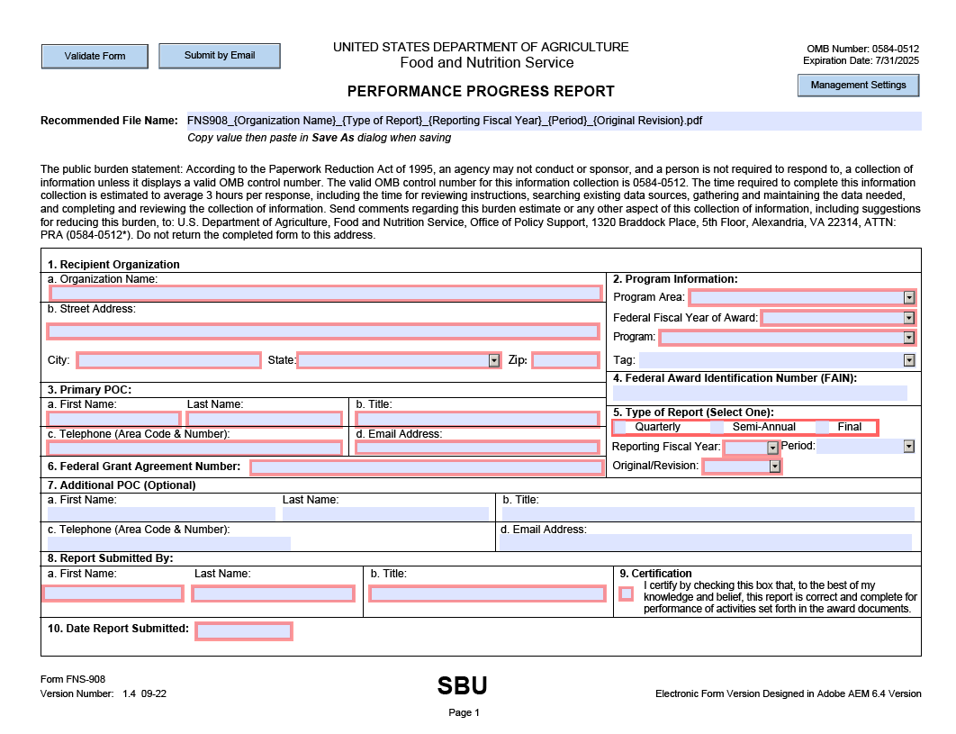

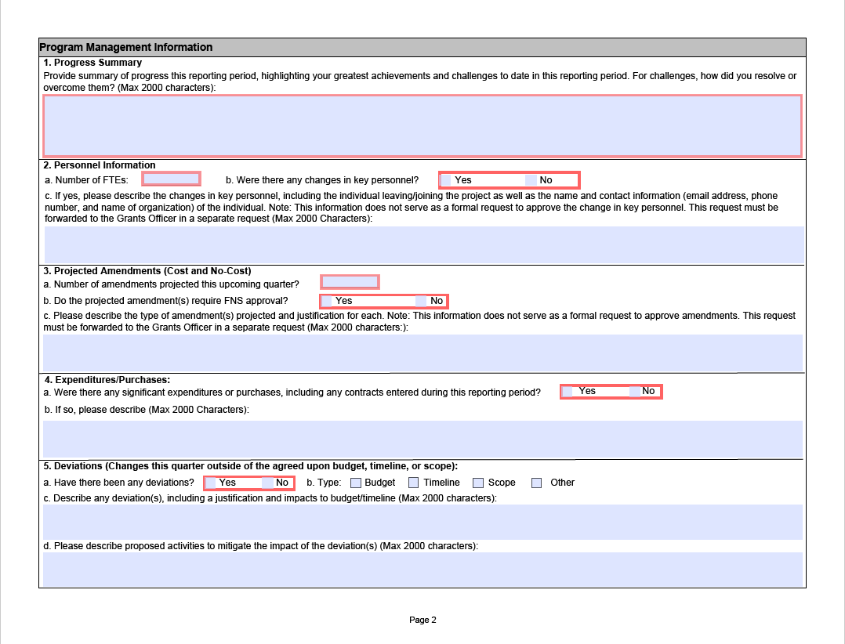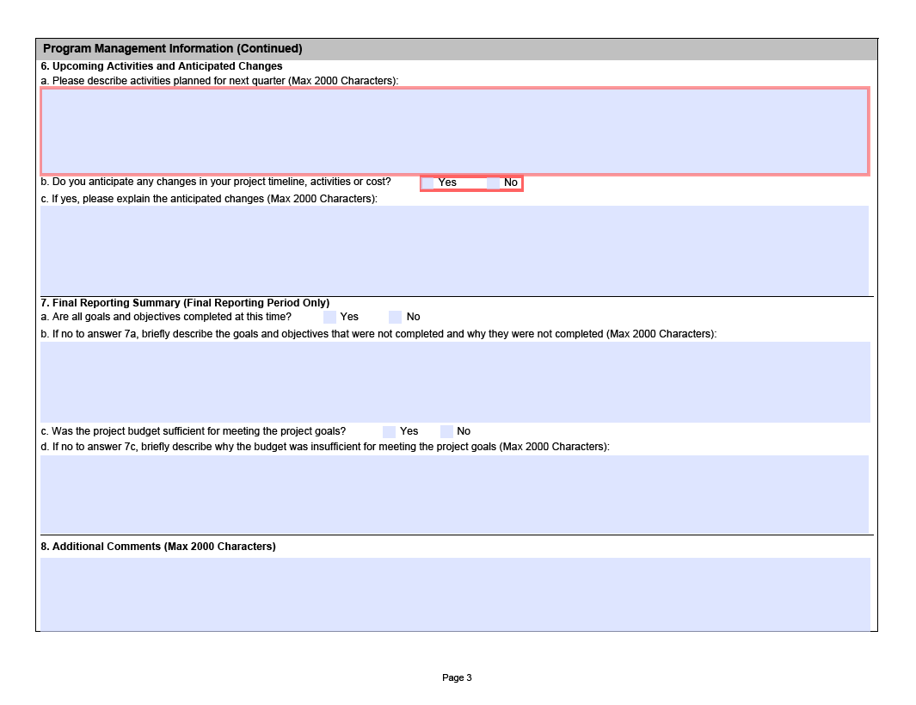
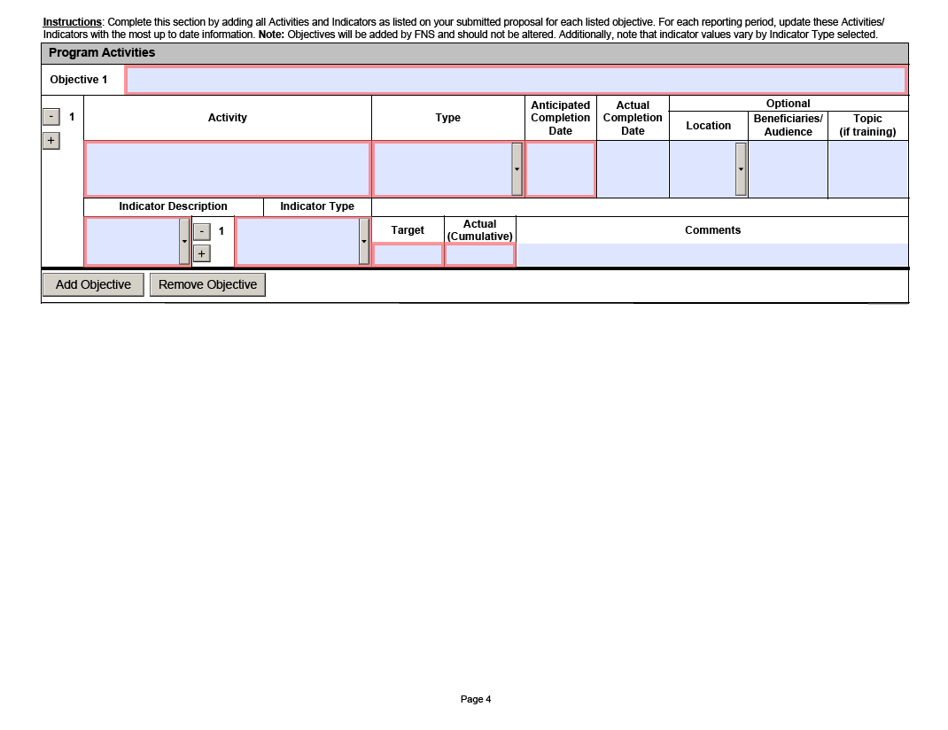

Please note that this document refers to FNS forms instead of FNA temporarily, as the agency works towards an official process to update reporting form names.

